|  |
| --- |
| Group 1 |
| Controlled Environment Monitors |
| **Production Document** |

Contents

**Manufacture** 2

Sensor Unit Manufacture 3

Sensor Unit Enclosure 3

Top Cover 4

Bottom Cover 6

Battery Cover 8

Battery Lock 10

Sensor Unit PCB Manufacture 11

Bill of Materials for PCB 11

Circuit Schematics 12

Hierarchical view 12

Battery Level Sensor 13

Power Regulator 13

Processor 13

Circuit Layout 14

Display Unit Manufacture 22

Display Unit Enclosure 22

Components 23

Top Cover 23

Bottom Cover 25

Battery Cover 27

Display Unit PCB Manufacture 29

Bill of Materials 29

Circuit Schematics 31

Hierarchical View 31

Alarm Unit 32

Battery Indicator 32

RF communication 32

Power regulator 33

Processor 33

Circuit Layout 34

**Testing** 40

Sensor Unit PCB Testing 41

Display Unit PCB Testing 44

**Assembly** 47

Sensor Unit Assembly 48

Assembly Steps 48

Display Unit Assembly 49

Assembly Steps 49

Processor Code 50

Sensor Unit Code 56

LCD CODE 57

|  |
| --- |
| Group 1 |
| Controlled Environment Monitors |
| **Manufacture** |

|  |
| --- |
|  |
|  |
|  |

# Sensor Unit Manufacture

## Sensor Unit Enclosure

Sensor Unit

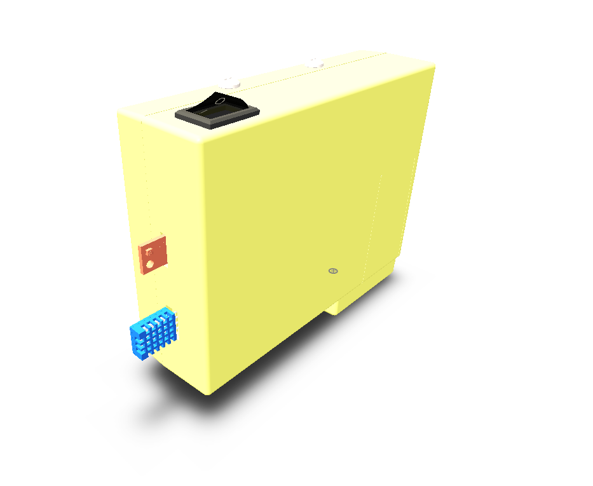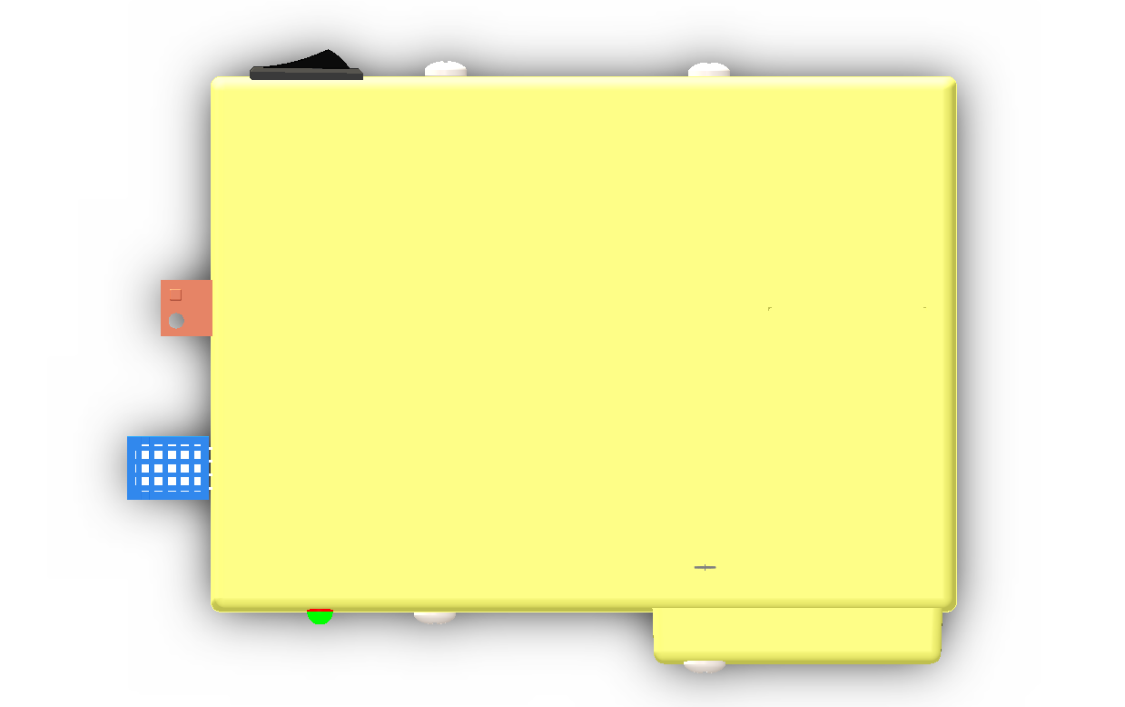

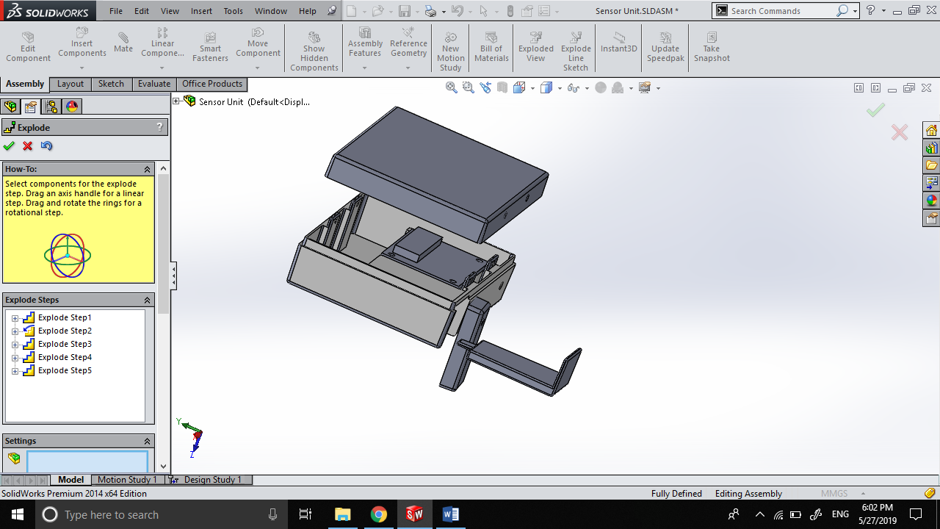

Components

The Sensor Unit Enclosure consists of 4 components that are to be manufactured by injection molding. All units are to be molded using hard plastic

Components to be molded are:

1. Top Cover
2. Bottom Cover
3. Battery Cover
4. Battery Lock

### Top Cover

Draft Analysis of Top Cover

Top Cover Mold Components

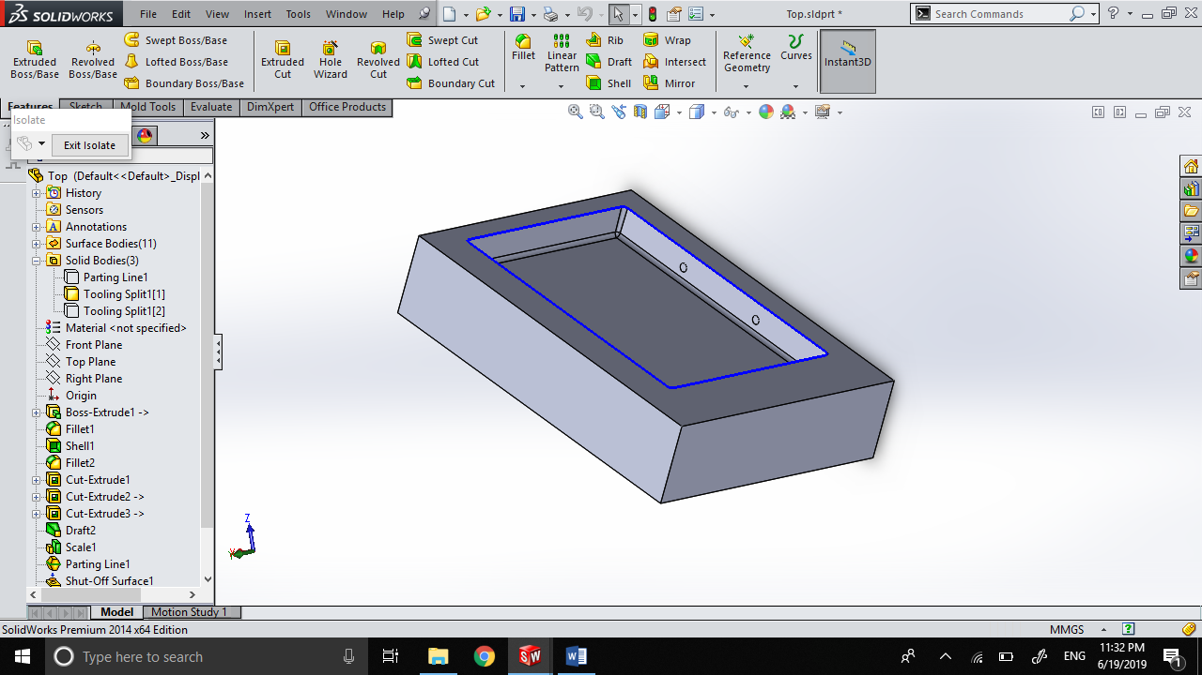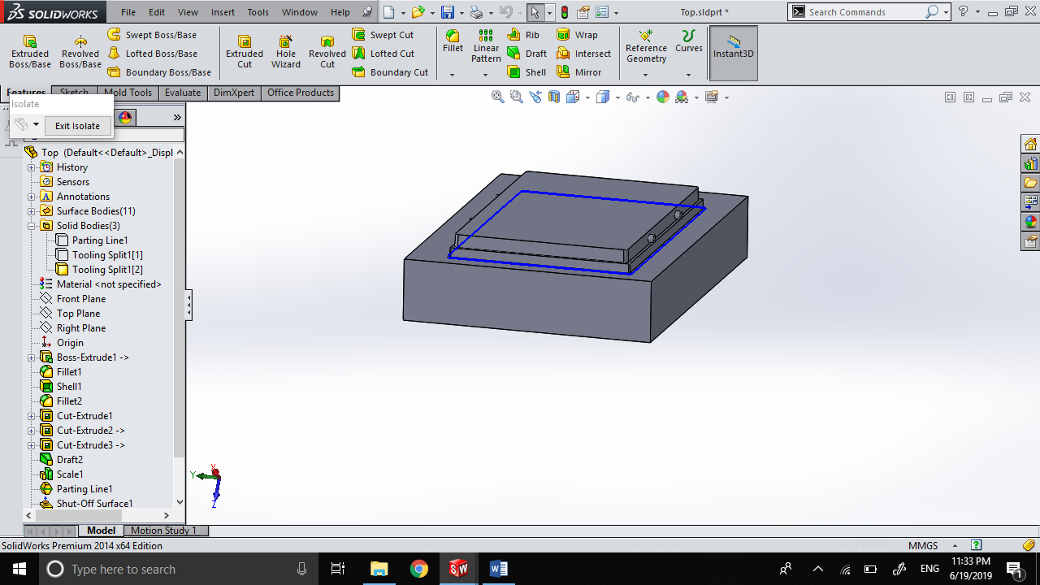

Core

Cavity

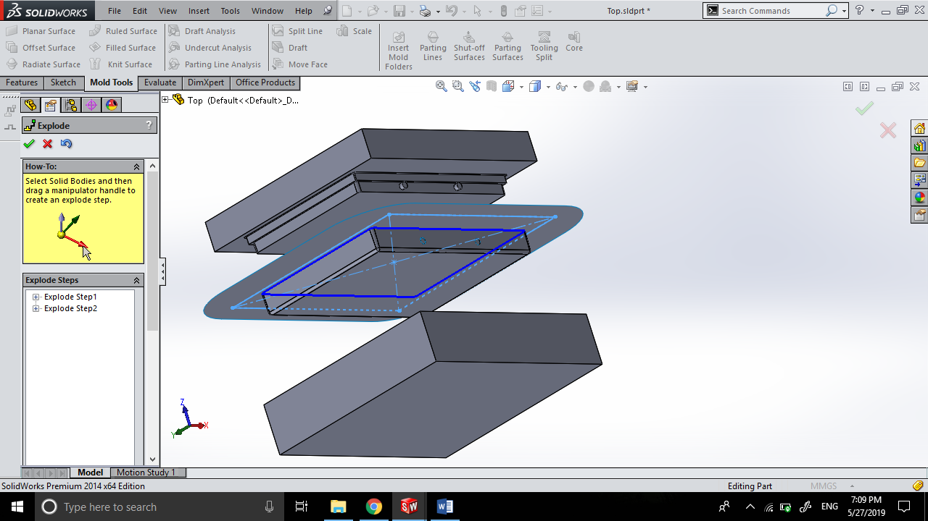

**Exploded View of Mold**

### Bottom Cover

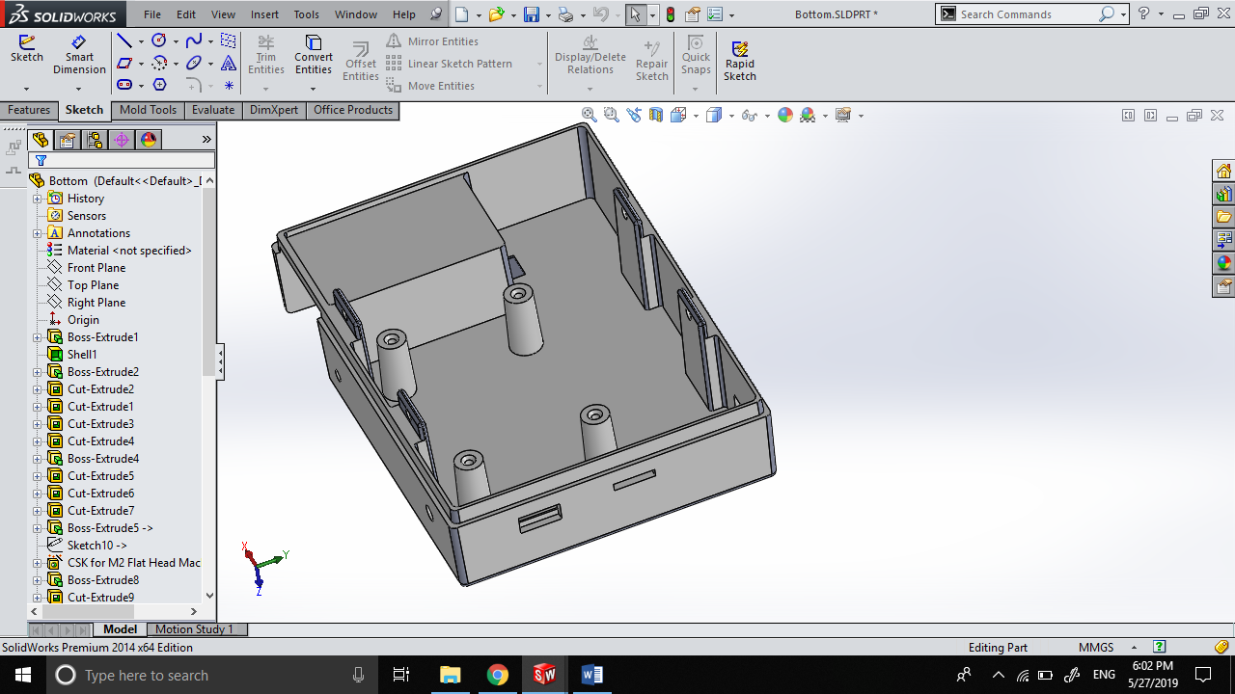

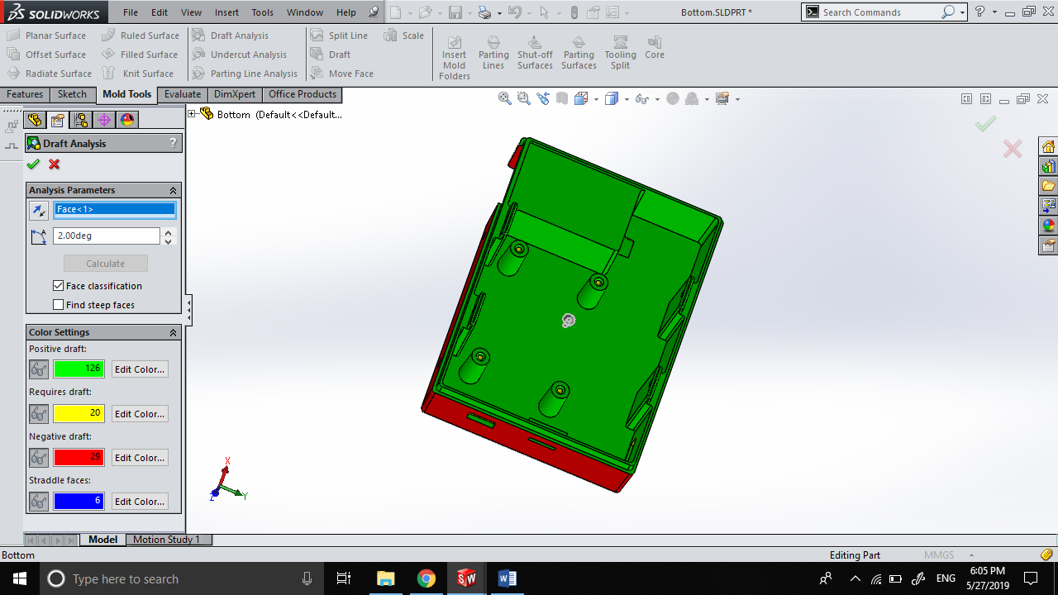Draft Analysis of Bottom Cover

Bottom Cover Mold Components

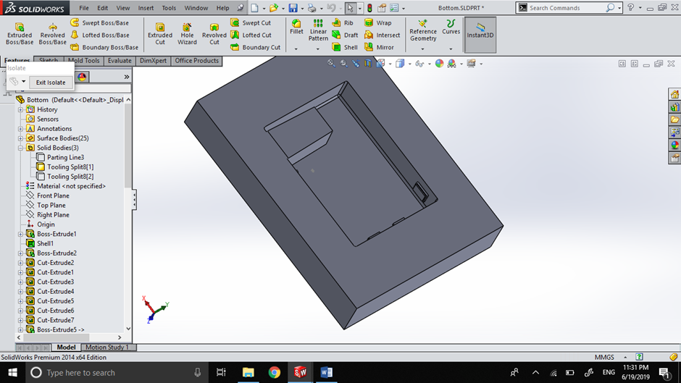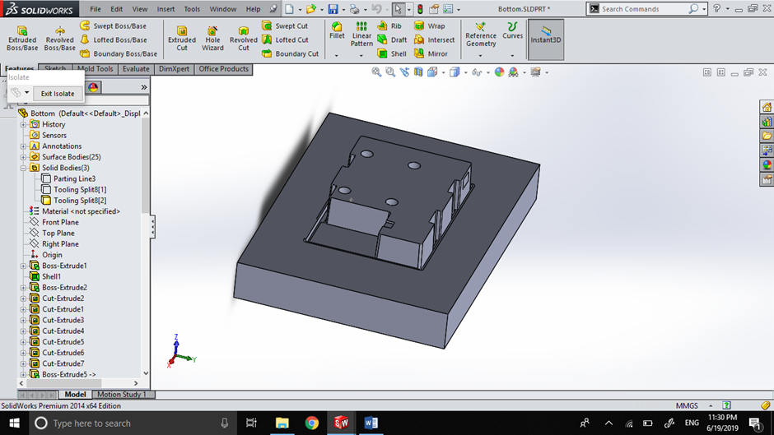

Core

Cavity

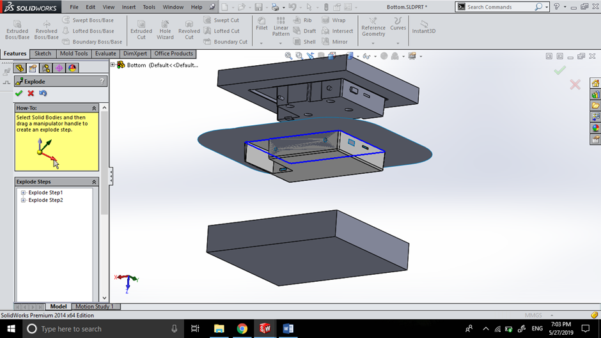

Exploded View of Mold

### Battery Cover

Draft Analysis of Battery Cover

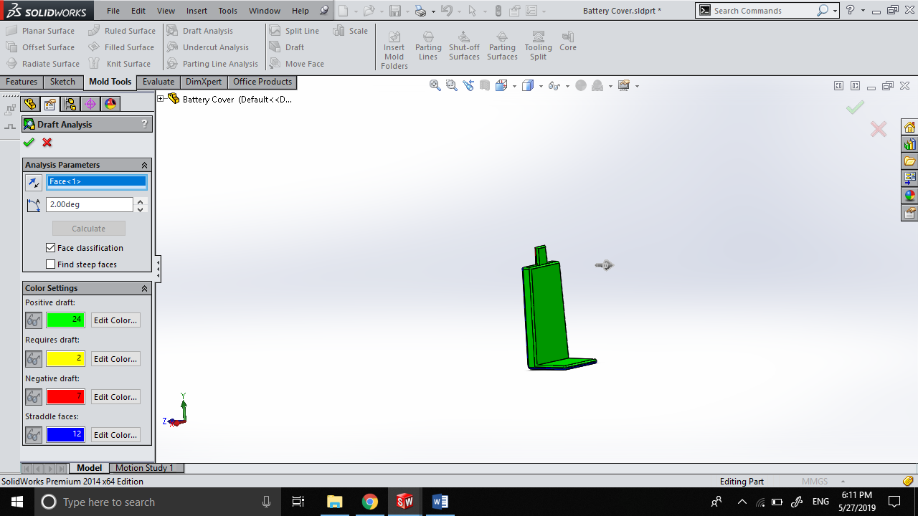

Battery Cover Mold Components

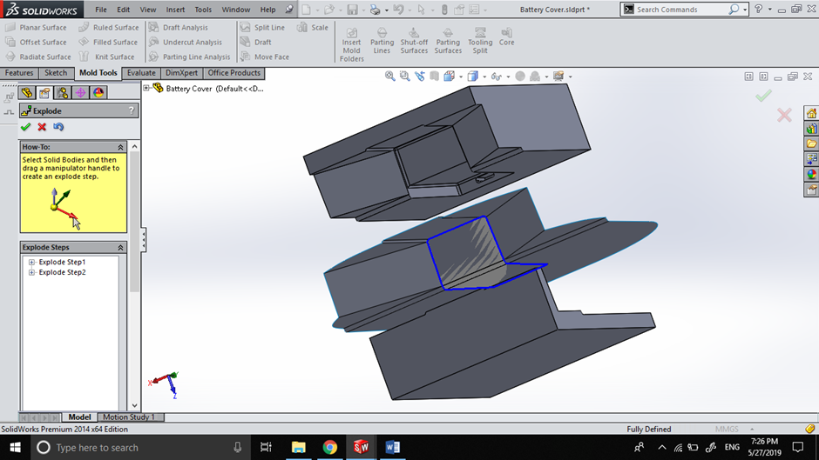

Exploded View of Mold

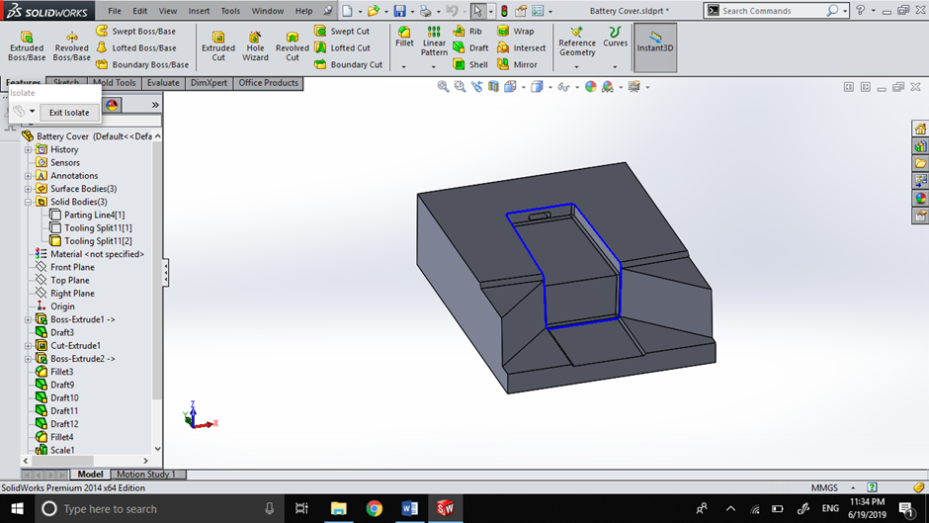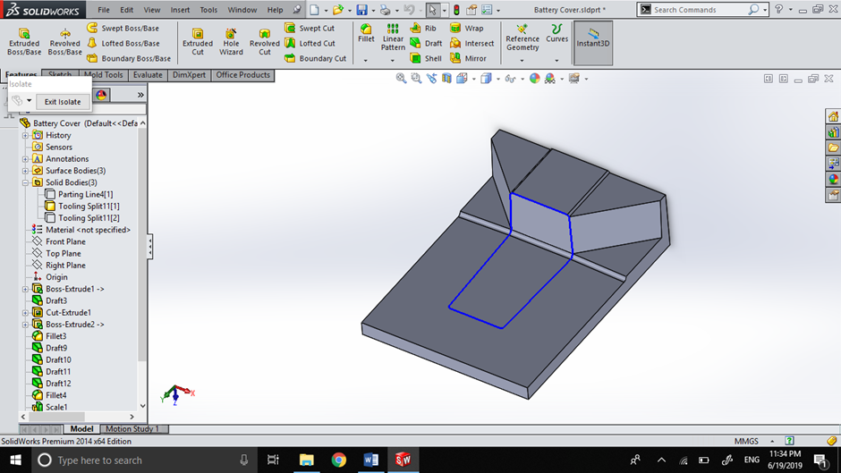

Core

Cavity

### Battery Lock

Draft Analysis of Battery Lock

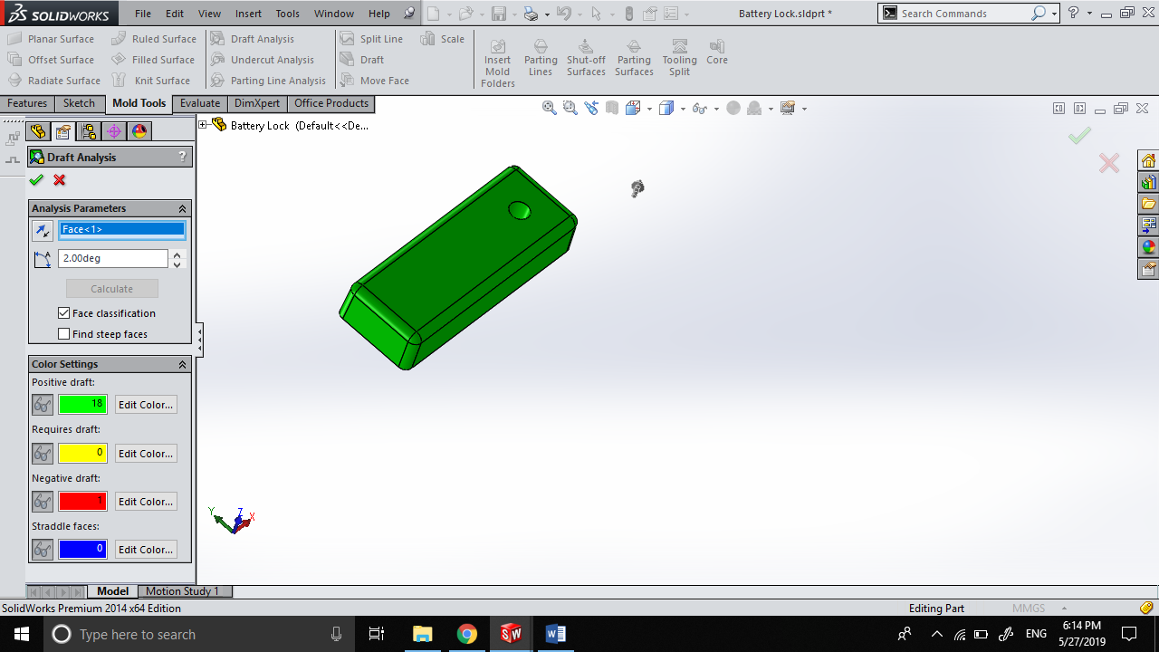

# Sensor Unit PCB Manufacture

## Bill of Materials for PCB

|  |  |  |  |  |  |
| --- | --- | --- | --- | --- | --- |
| **SYM_NAME** | **COMP_DEVICE_TYPE** | **COMP_VALUE** | **COMP_TOL** | **COMP_CLASS** | **REFDES** |
| RESISTOR | CAP NP_RESISTOR_0.33UF | 0.33uF |  | IC | C11 |
| RESISTOR | CAP NP_RESISTOR_0.1UF | 0.1uF |  | IC | C12 |
| RESISTOR | CAP NP_RESISTOR_22PF | 22pF |  | IC | C13 |
| RESISTOR | CAP NP_RESISTOR_22PF | 22pF |  | IC | C14 |
| RESISTOR | DIODE ZENER_0_RESISTOR_1N4735A | 1N4735A |  | IC | D1 |
| JACK | HEADER 2_JACK_HEADER 2 | HEADER 2 |  | IC | J1 |
| CONN2 | HEADER 2_CONN2_HEADER 2 | HEADER 2 |  | IC | J2 |
| CONN2 | HEADER 2_CONN2_HEADER 2 | HEADER 2 |  | IC | J3 |
| CONN4 | HEADER 4_CONN4_HEADER 4 | HEADER 4 |  | IC | J4 |
| CONN3 | HEADER 3_CONN3_HEADER 3 | HEADER 3 |  | IC | J5 |
| CONN3 | HEADER 3_CONN3_HEADER 3 | HEADER 3 |  | IC | J6 |
| CONN3 | HEADER 3_CONN3_TRANSMITTER | Transmitter |  | IC | J7 |
| REGULATOR | LM7805CTNOPB_0_REGULATOR_LM7805 | LM7805CTNOPB |  | IC | Q11 |
| BC547 | 2N3904TFR_BC547_BC547A | BC547A |  | IC | Q12 |
| BC547 | 2N3904TFR_BC547_BC547A | BC547A |  | IC | Q13 |
| RESISTOR | RESISTOR_RESISTOR_7.5K | 7.5K |  | IC | R11 |
| RESISTOR | RESISTOR_RESISTOR_39K | 39K |  | IC | R12 |
| RESISTOR | RESISTOR_RESISTOR_680 | 680 |  | IC | R13 |
| RESISTOR | RESISTOR_RESISTOR_30K | 30K |  | IC | R14 |
| RESISTOR | RESISTOR_RESISTOR_RESISTOR | RESISTOR |  | IC | R15 |
| RESISTOR | RESISTOR_RESISTOR_10K | 10k |  | IC | R16 |
| RESISTOR | SW PUSHBUTTON_0_RESISTOR_RESET | RESET |  | IC | SW1 |
| SCREWCONN | SW PUSHBUTTON_0_SCREWCONN_RESET | RESET |  | IC | SW2 |
| ICSOCKET | ATMEGA32A-PU_0_ICSOCKET_ATMEGA3 | ATMEGA32A-PU |  | IC | U1 |
| RESISTOR | CRYSTAL_RESISTOR_16MHZ | 16MHz |  | IC | Y1 |

### Bill of Materials - Non-PCB Components

|  |  |  |
| --- | --- | --- |
| **COMPONENT NAME** | **MANUFACTURER** | **QUANTITY** |
| ATMEGA32A | MICROCHIP | 1 |
| DHT11 | ADAFRUIT | 1 |
| TEMT6000 | ADAFRUIT | 1 |
| SOIL MOISTURE SENSOR | ADAFRUIT | 1 |
| ROCKER SWITCH | NTE ELECTRONICS | 1 |
| 433 MHZ TRANSMITTER | ADAFRUIT | 1 |
| LED GREEN | GENERIC | 1 |

## Circuit Schematics

### Hierarchical view

### Battery Level Sensor

### Power Regulator

### A close up of a map Description automatically generatedProcessor

## Circuit Layout

Silkscreen

Sensor Unit Top

INSert 7 pages

# Display Unit Manufacture

## Display Unit Enclosure

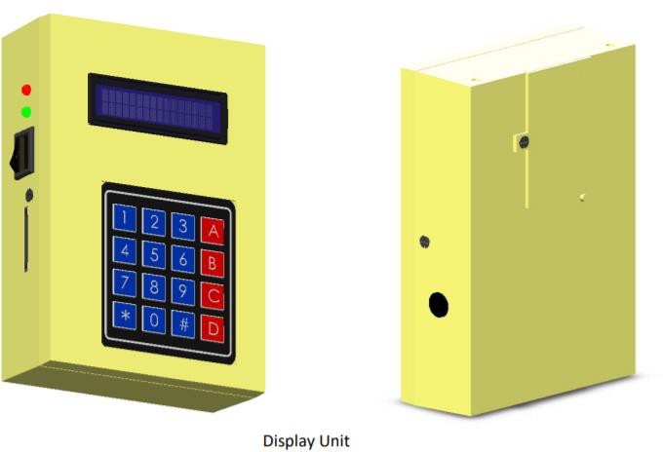

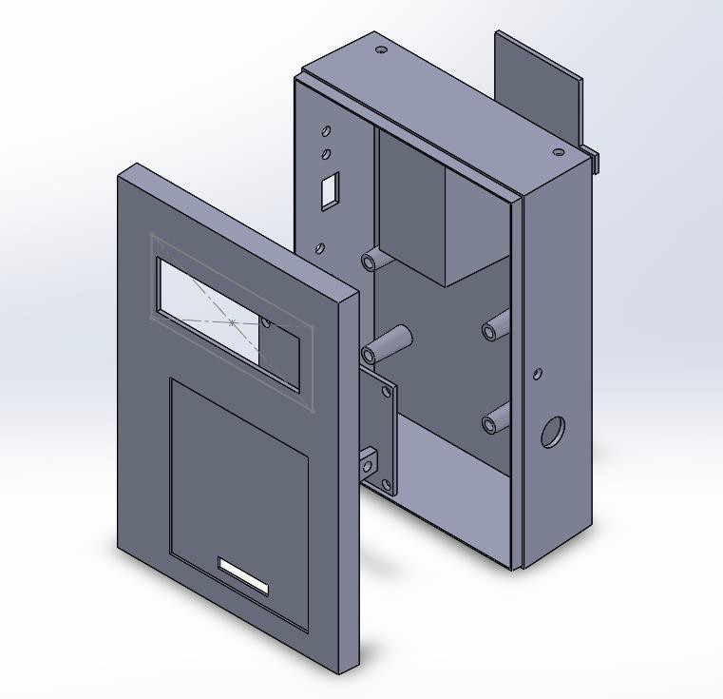

## Components

The display unit enclosure consists of 3 components that are manufactured by injection molding. All units are to be molded using hard plastic.

1. Top Cover
2. Bottom Cover
3. Battery Cover

## Top Cover

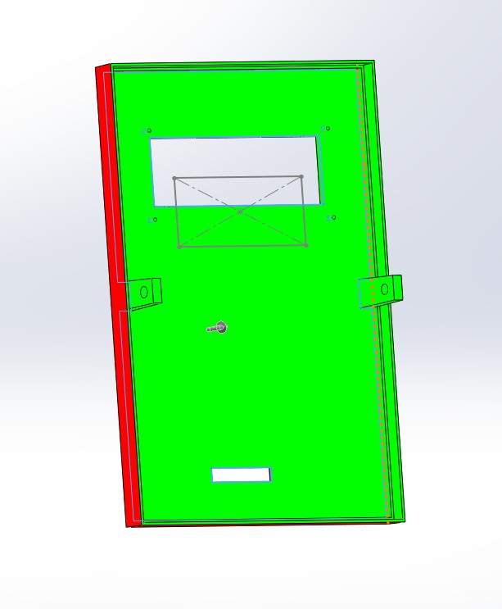Draft Analysis of Top Cover

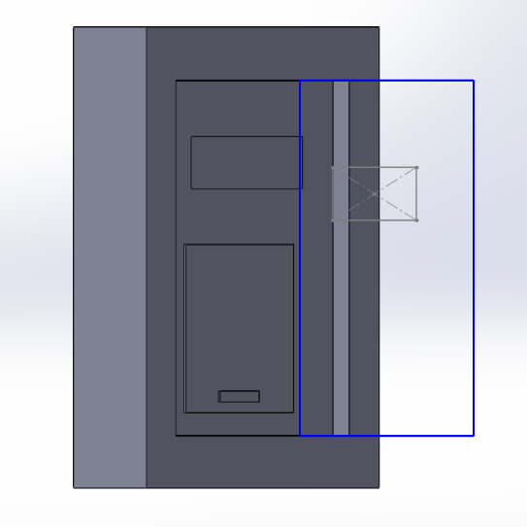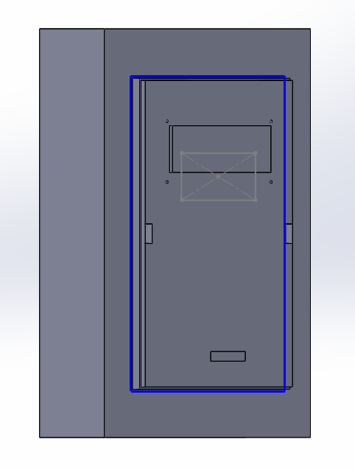Mold Components of Top Cover

Cavity Core

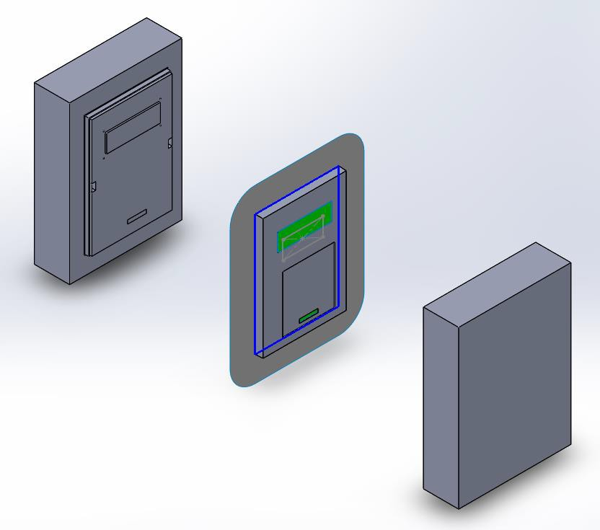

Exploded view of mold

## Bottom Cover

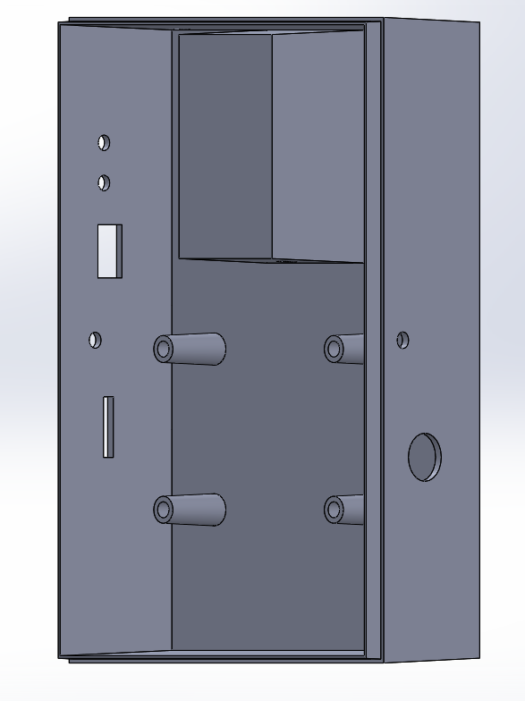

Draft Analysis of Bottom Cover

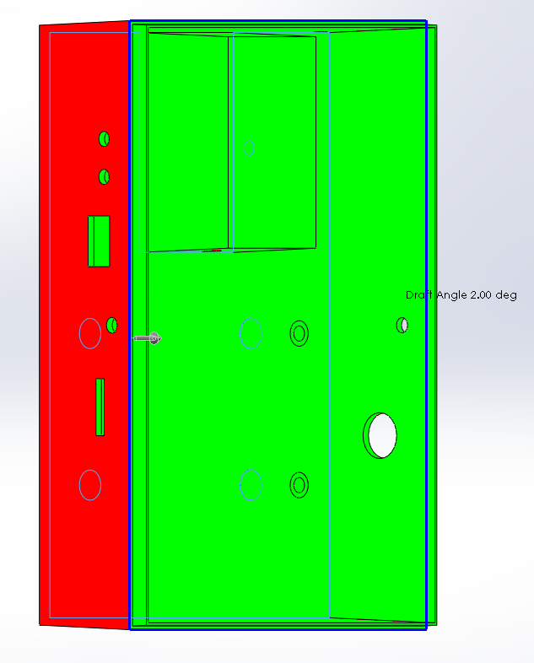

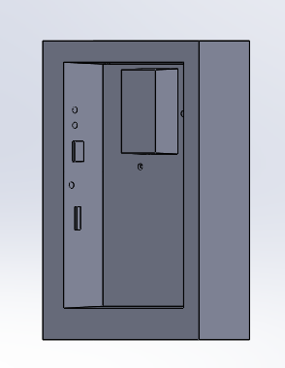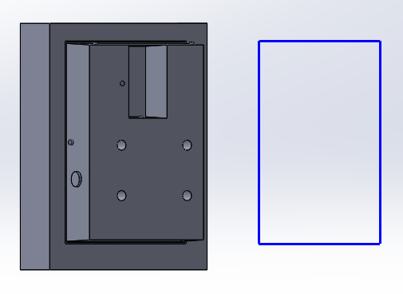Mold Components

Core Cavity

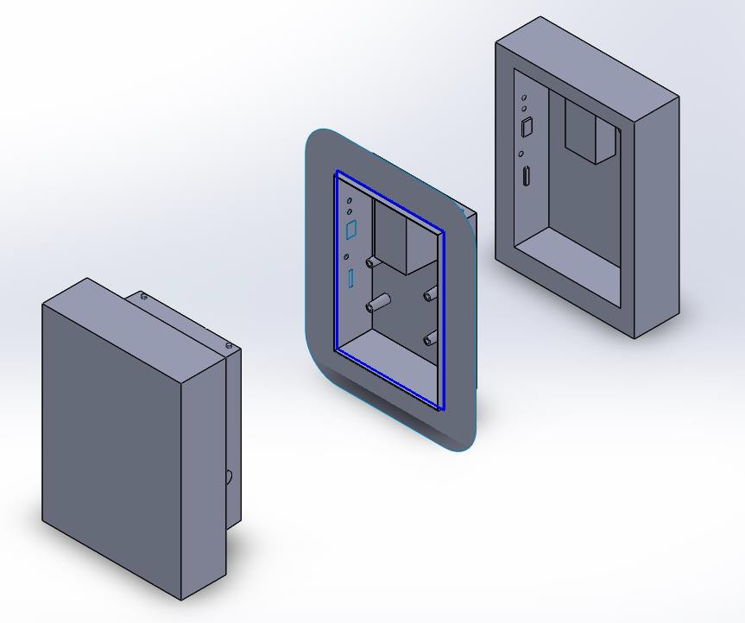

Exploded view of Mold

## Battery Cover

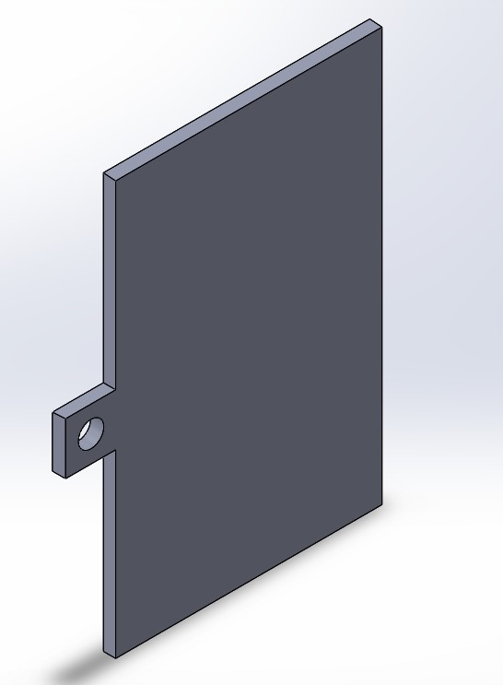

Draft Analysis of Battery Cover

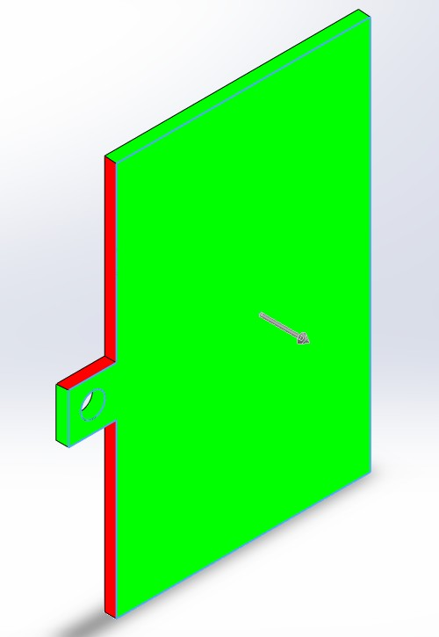

Mold Components of Battery Cover

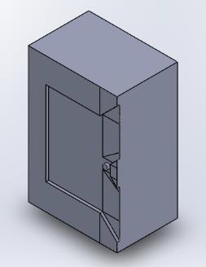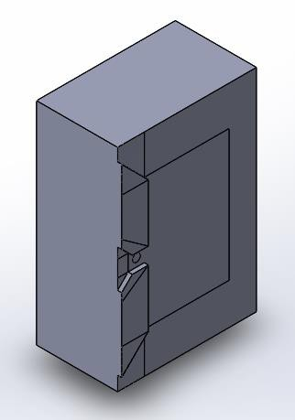

Core Cavity

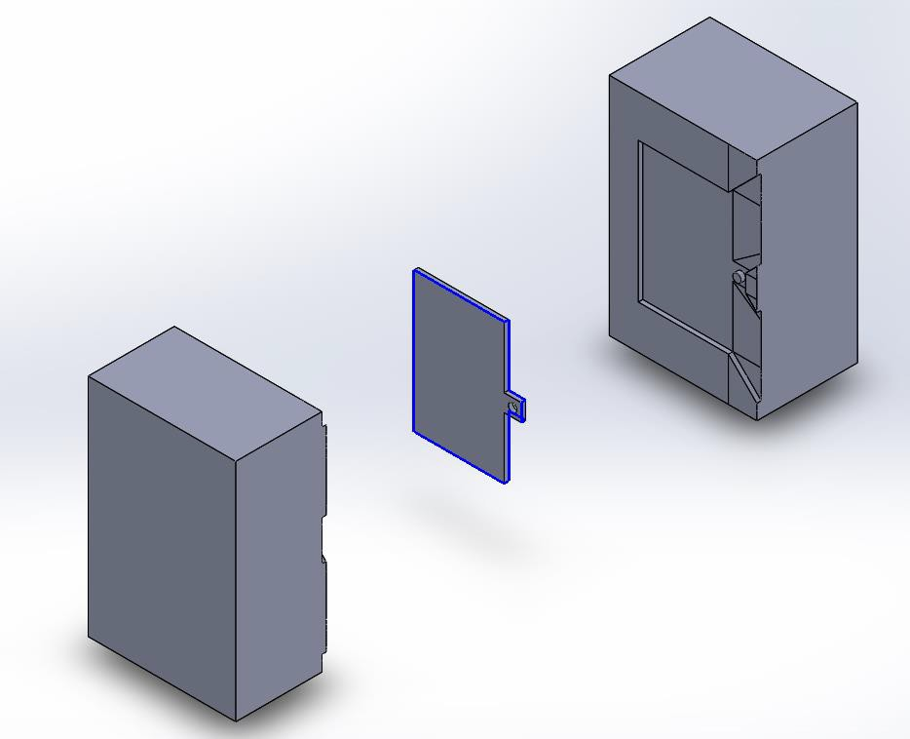

Exploded view of Mold

# Display Unit PCB Manufacture

|  |  |  |  |  |  |
| --- | --- | --- | --- | --- | --- |
| **SYM_NAME** | **COMP_DEVICE_TYPE** | **COMP_VALUE** | **COMP_TOL** | **COMP_CLASS** | **REFDES** |
| RESISTOR | C_RESISTOR_0.33UF | 0.33uF |  | IC | C1 |
| RESISTOR | C_RESISTOR_0.33UF | 0.33uF |  | IC | C2 |
| RESISTOR | C_RESISTOR_22PF | 22pF |  | IC | C3 |
| RESISTOR | C_RESISTOR_22PF | 22pF |  | IC | C4 |
| RESISTOR | 1N4740A_RESISTOR_1N4740A | 1N4740A |  | IC | D1 |
| JACK | HEADER 2_JACK_HEADER 2 | HEADER 2 |  | IC | J1 |
| CONN16 | HEADER 16_CONN16_LCD | LCD |  | IC | J2 |
| CON6 | HEADER 6_CON6_HEADER 6 | HEADER 6 |  | IC | J3 |
| CONN2 | HEADER 2_CONN2_HEADER 2 | HEADER 2 |  | IC | J4 |
| CONN2 | HEADER 2_CONN2_HEADER 2 | HEADER 2 |  | IC | J5 |
| CONN8 | HEADER 8_CONN8_HEADER 8 | HEADER 8 |  | IC | J6 |
| CONN2 | HEADER 2_CONN2_HEADER 2 | HEADER 2 |  | IC | J7 |
| OPTO | CONN MOD 6-4_J_OPTO_CONN MOD 6- | CONN MOD 6-4_J |  | IC | J8 |
| CONN2 | CON2_CONN2_CON2 | CON2 |  | IC | J9 |
| CONN4 | HEADER 4_CONN4_HEADER 4 | HEADER 4 |  | IC | J10 |
| BC547 | BC547A_BC547_BC547A | BC547A |  | IC | Q1 |
| BC547 | BC547A_BC547_BC547A | BC547A |  | IC | Q2 |
| TRIMPOT | POT_TRIMPOT_1K | 1K |  | IC | R1 |
| RESISTOR | R_RESISTOR_1K | 1k |  | IC | R2 |
| RESISTOR | R_RESISTOR_1K | 1k |  | IC | R3 |
| RESISTOR | R_RESISTOR_680 | 680 |  | IC | R4 |
| RESISTOR | R_RESISTOR_680 | 680 |  | IC | R5 |
| RESISTOR | R_RESISTOR_30K | 30K |  | IC | R6 |
| RESISTOR | R_RESISTOR_39K | 39K |  | IC | R7 |
| RESISTOR | R_RESISTOR_7.5K | 7.5K |  | IC | R8 |
| RESISTOR | R_RESISTOR_10K | 10K |  | IC | R9 |
| RESISTOR | SW_PB_SPST_RESISTOR_SW_PB_SPST | SW_PB_SPST |  | IC | SW1 |
| REGULATOR | LM7805C_0_REGULATOR_LM7805C | LM7805C |  | IC | U1 |
| ICSOCKET | ATMEGA32A-PU_ICSOCKET_ATMEGA32A | ATMEGA32A-PU |  | IC | U2 |
| CRYSTAL | CRYSTAL_CRYSTAL_CRYSTAL | CRYSTAL |  | IC | Y1 |

## Bill of Materials

### 

### External Component Bill of Materials

|  |  |  |
| --- | --- | --- |
| **Component Name** | **Manufacturer** | **Quantity** |
| ATMega32A | Microchip | 1 |
| Rocker Switch | NTE Electronics | 1 |
| 433 MHz Receiver | AdaFruit | 1 |
| SD Card Reader | Kingston | 1 |
| 16x2 LCD | XIAMEN AMOTEC | 1 |
| 4x4 Keypad | XIAMEN AMOTEC | 1 |

## Circuit Schematics

### Hierarchical View

### Alarm Unit

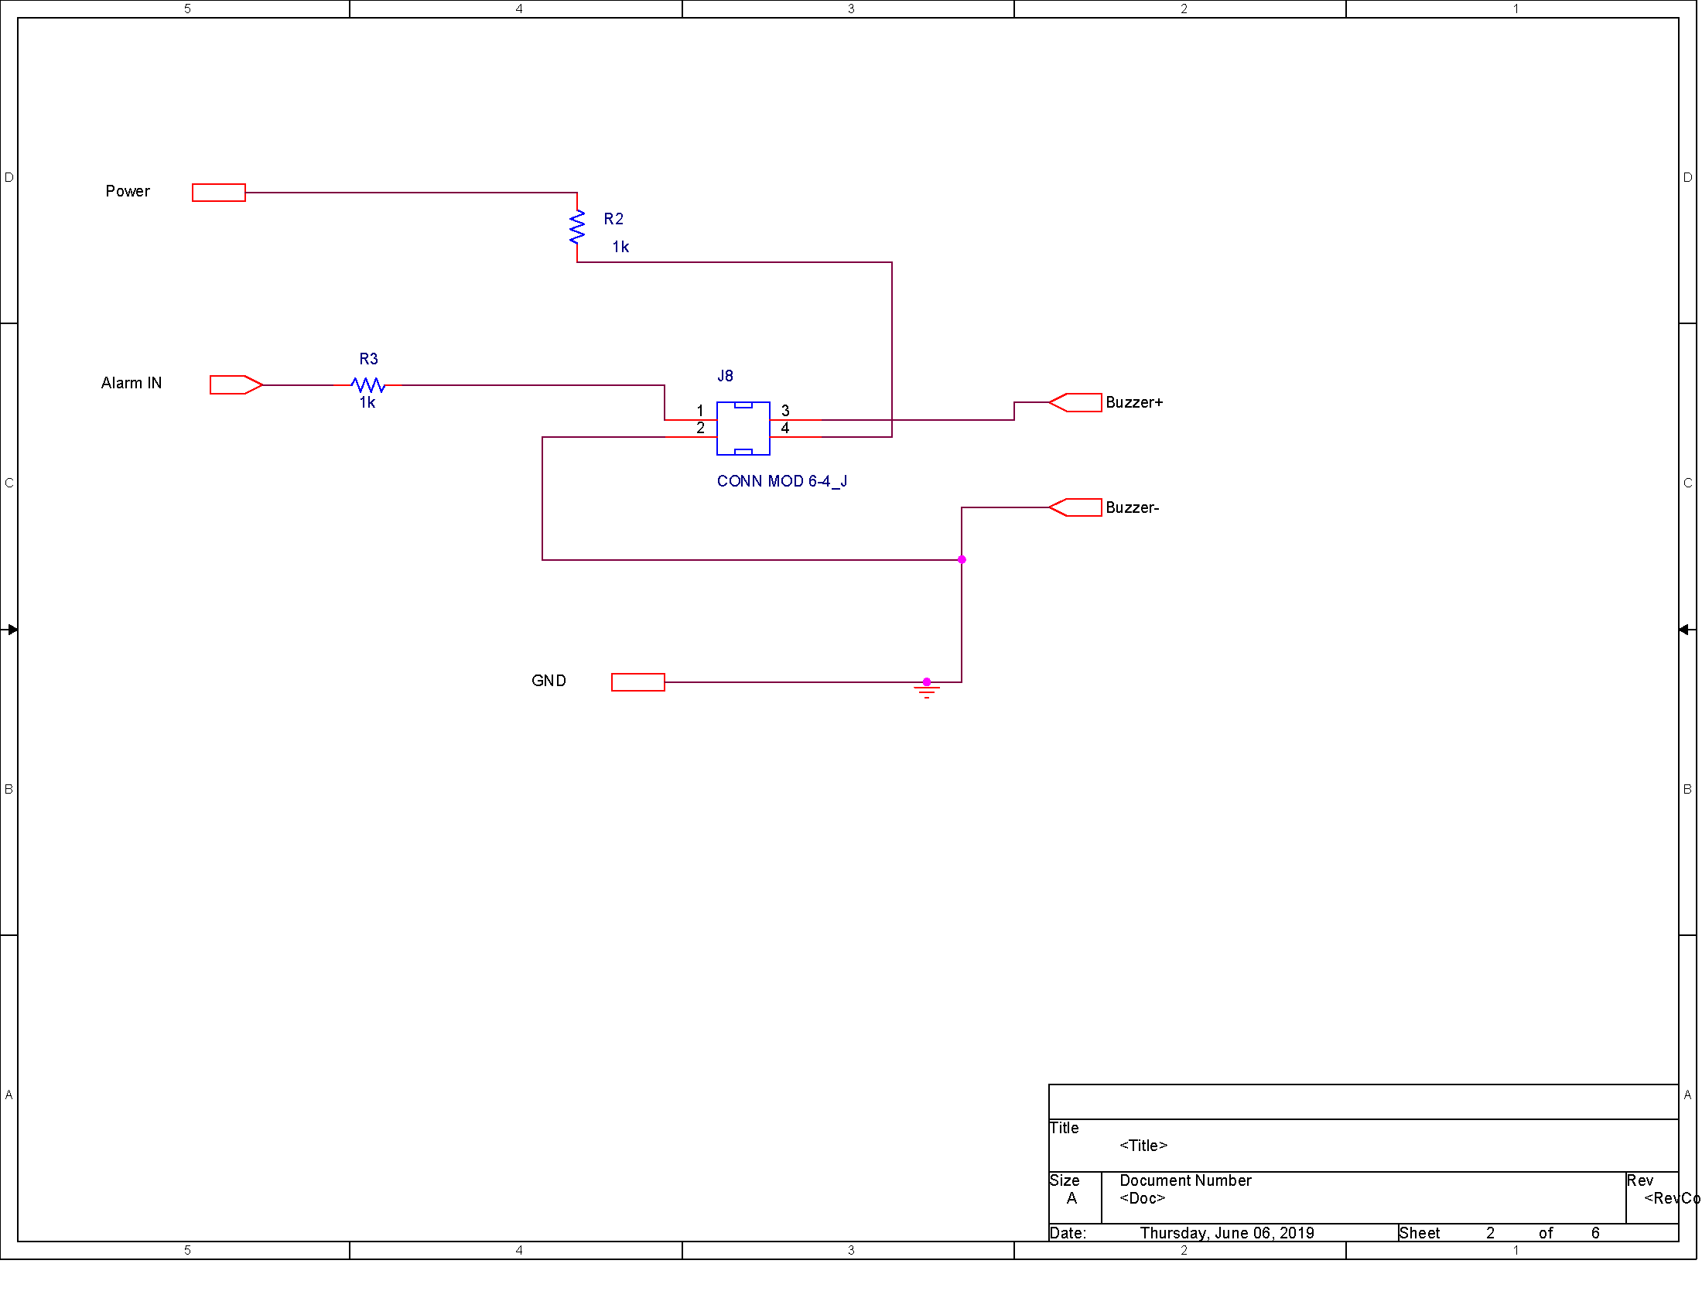

### Battery Indicator

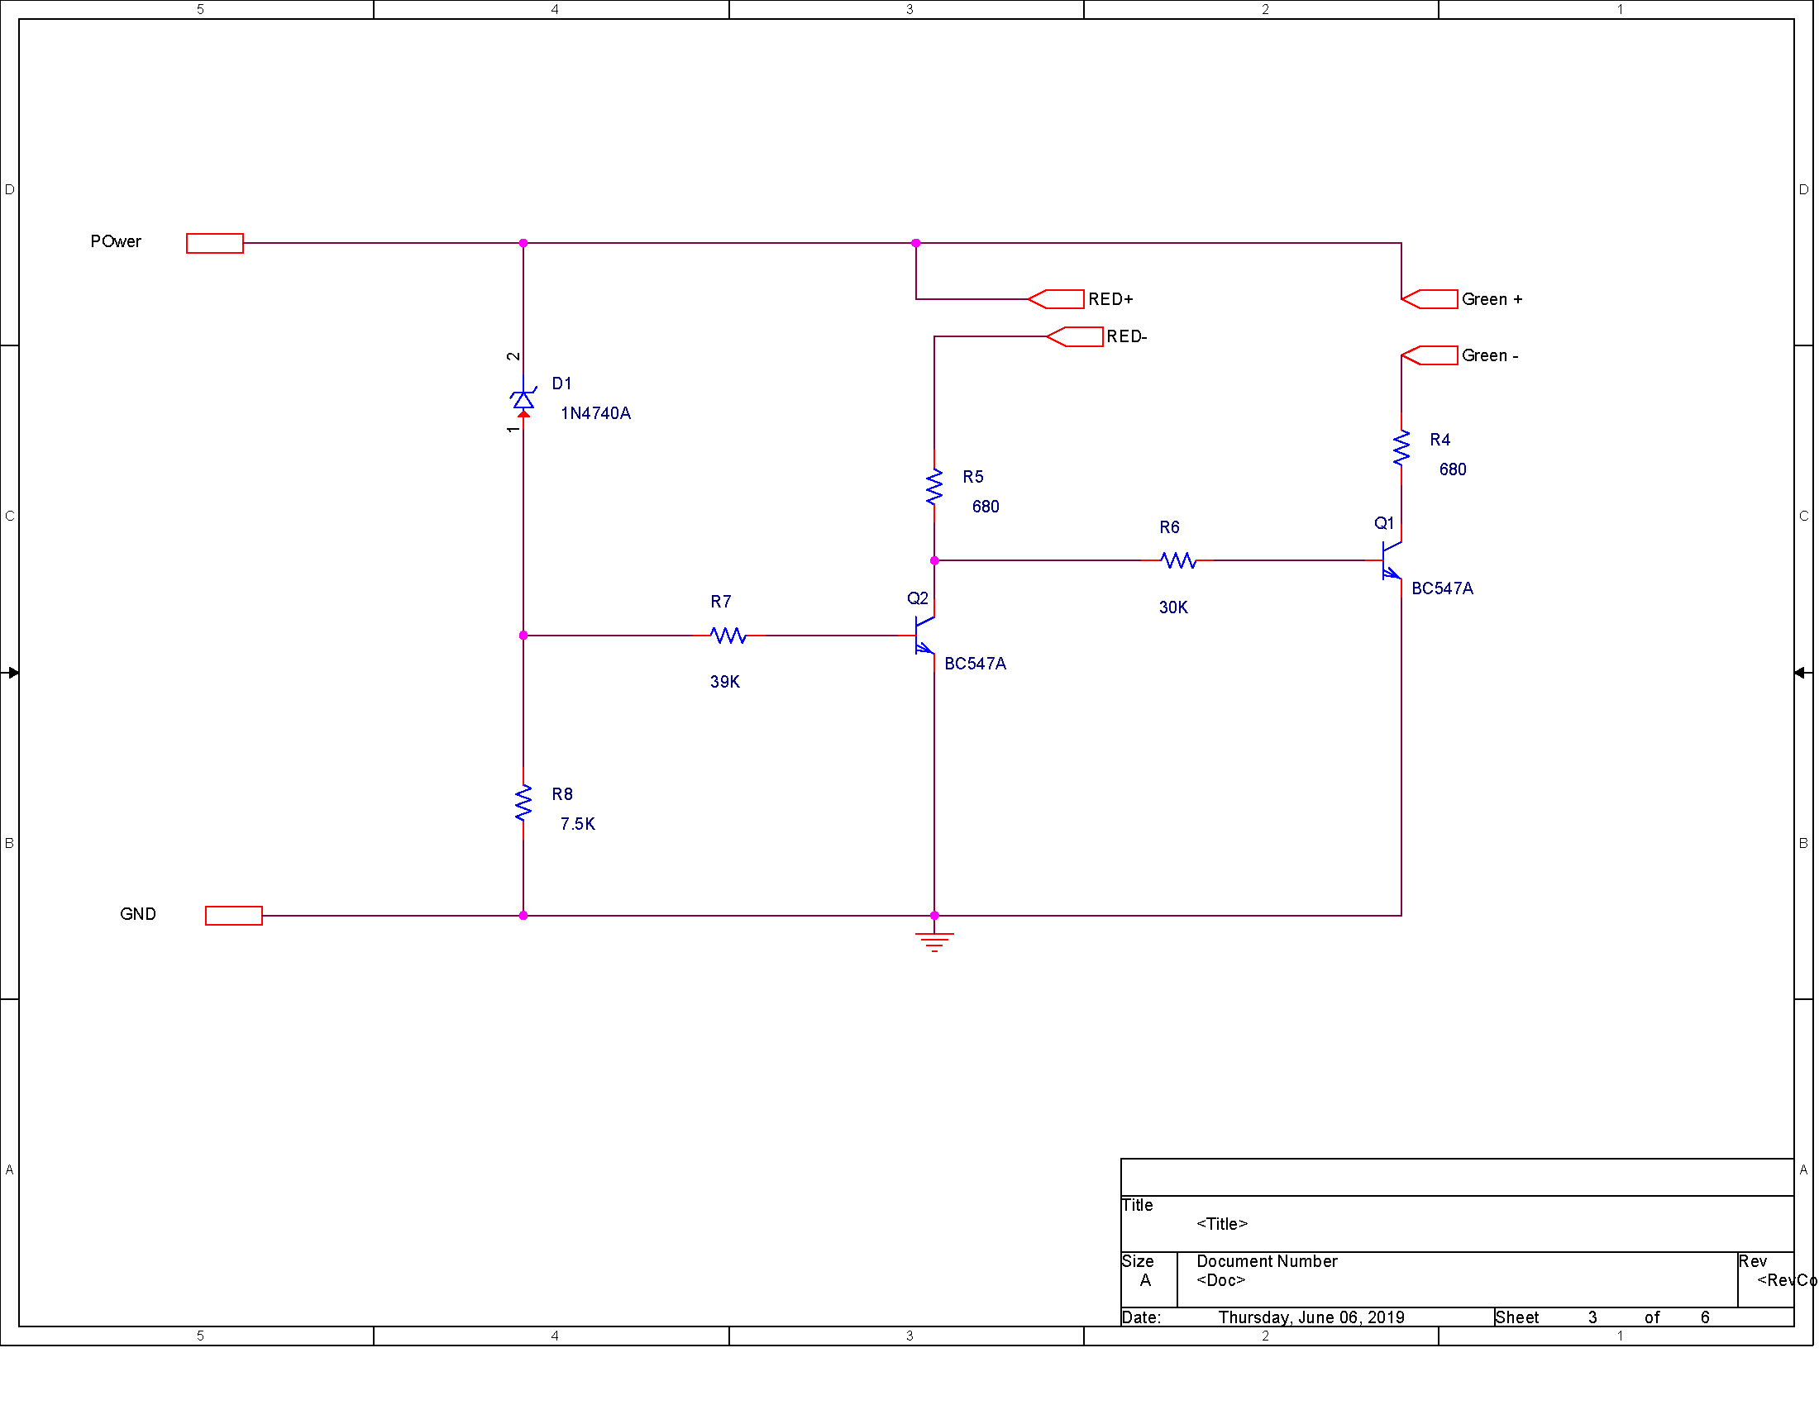

### RF communication

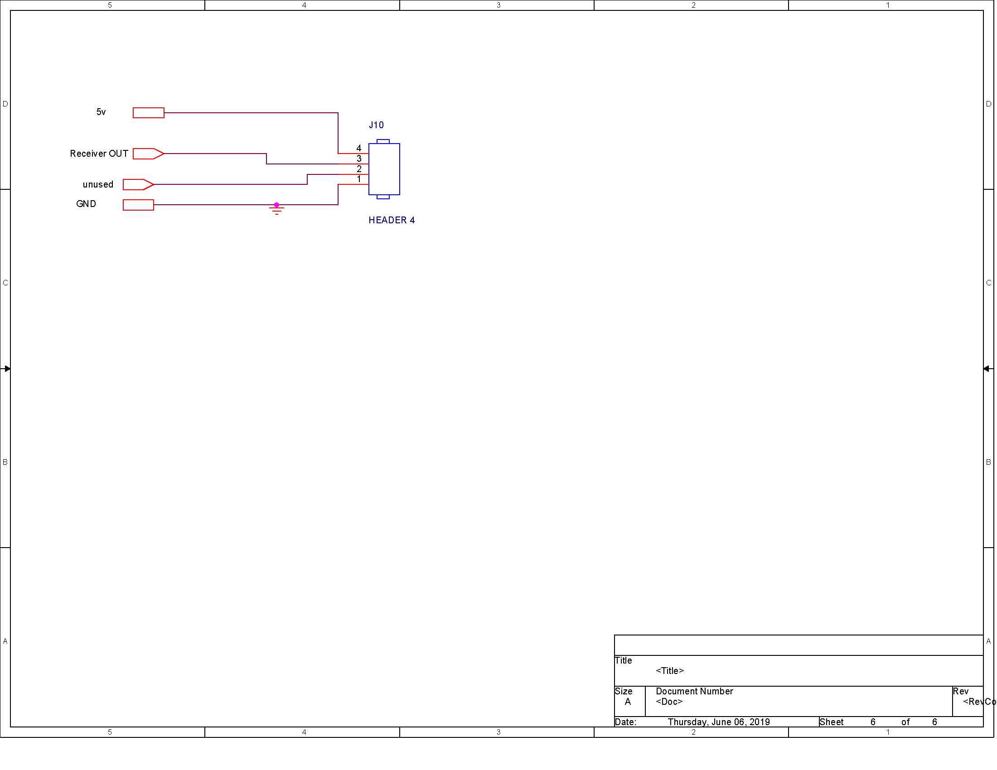

### Power regulator

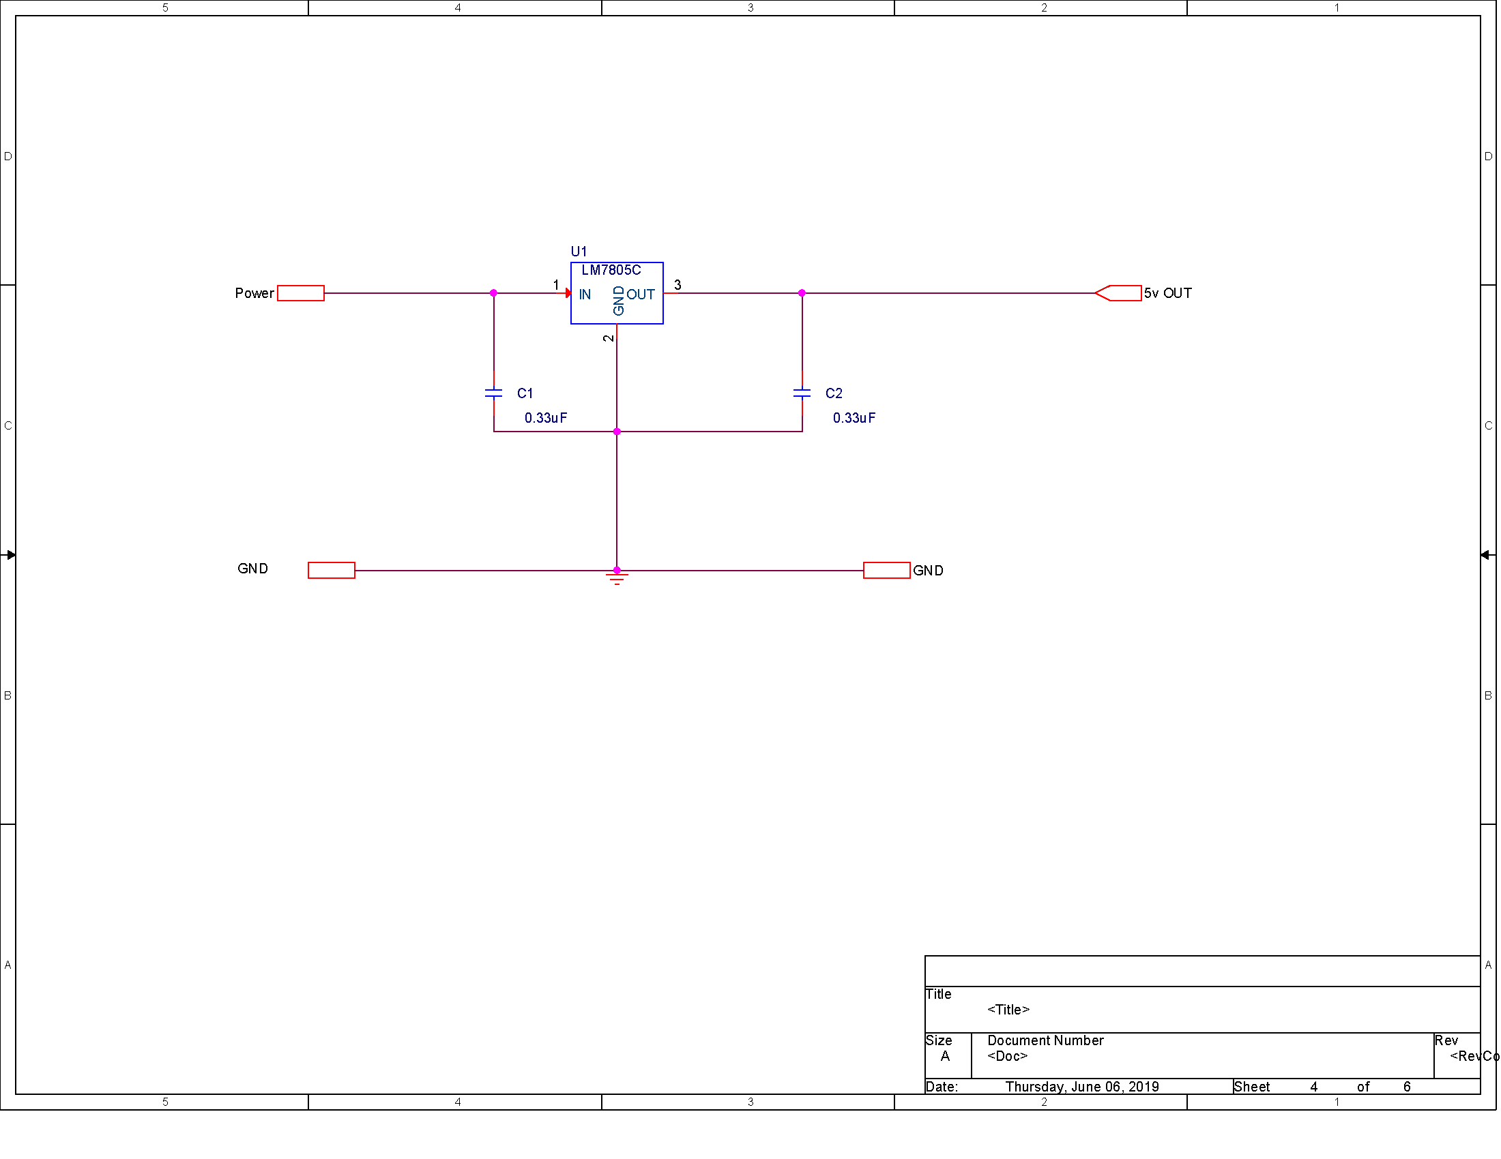

### Processor

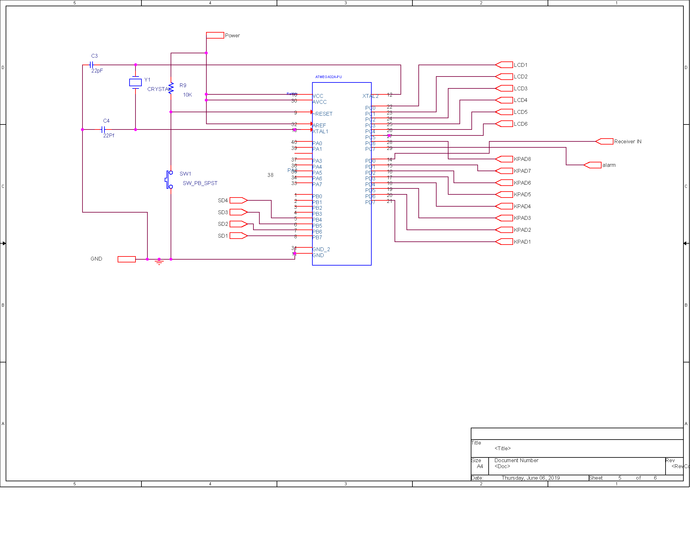

## Circuit Layout

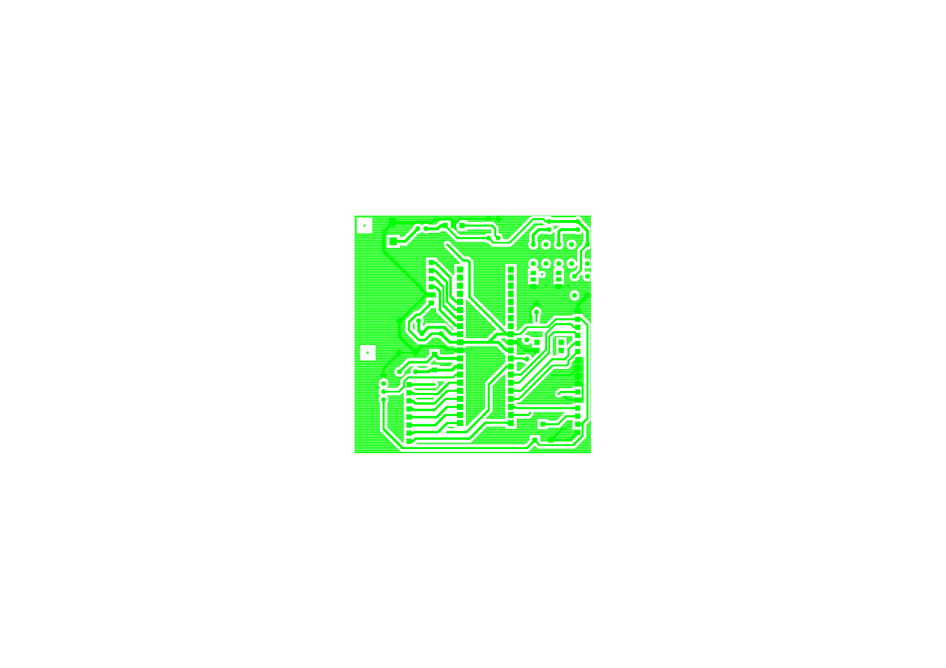Display Unit BottomSilkscreen

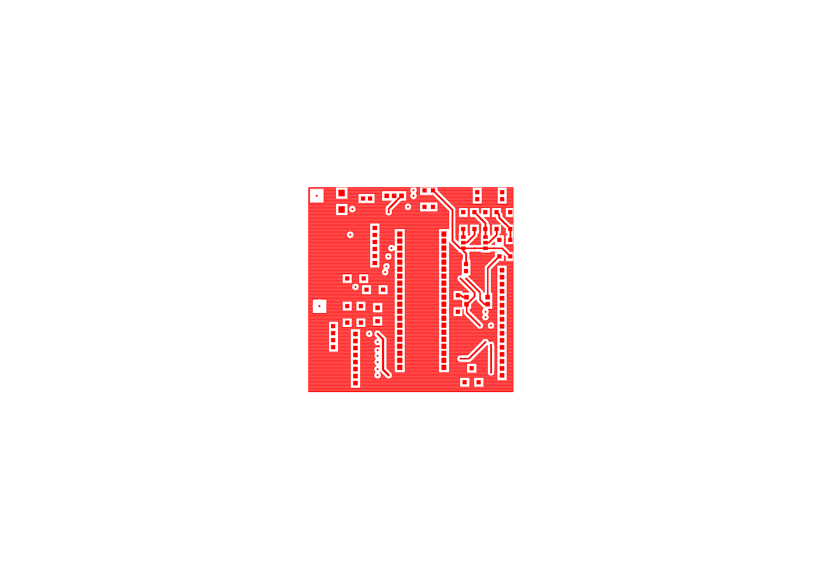Display Unit Top

INSert 5 pages

|  |
| --- |
| Group 1 |
| Controlled Environment Monitors |
| **Testing** |

## Sensor Unit PCB Testing

Testprep General Analysis ...

|  |  |  |
| --- | --- | --- |
| Total number of nets | ... | 19 |
| Total number of nets tested | ... | 3 |
| Total number of nets not tested | ... | 15 |
| Total number of nets flagged with NO_TEST property | ... | 1 |
| Total number of nets testable (tested + not tested) | ... | 18 |
| Percentage of all nets tested | ... | 15.79 percent |
| Percentage of testable nets tested | ... | 16.67 percent |
| Nets requiring more than one testprobe: |  |  |

Required Actual Net Name

-------- ------ --------

6 0 N06627

6 0 N07080

6 0 N07092

|  |  |  |
| --- | --- | --- |
| Total number of testprobes on TOP side | ... | 0 ( 0.00 percent) |
| Total number of testprobes on BOTTOM side | ... | 6 (100.00 percent) |
| Total number of testprobes on pins | ... | 0 |
| Total number of testprobes on vias | ... | 6 |

WARNING: There are 6 testprobes with no assigned probe type. Minimum pad size for probing ... 0 MM

|===========================================================================================================================================================

| |

| Nets currently under test for TOP side ...

| |

|===========================================================================================================================================================

| Net Name | QUANTITY | Number | Type | Pad Size | Location | Reference Designation |

|===========================================================================================================================================================

Total number of testpoints on TOP side = 0

|==========================================================================================================================================================

| |

| Nets currently under test for BOTTOM side ...

| |

|===========================================================================================================================================================

| Net Name | QUANTITY | Number | Type | Pad Size | Location | Reference Designation |

|===========================================================================================================================================================

|  |  |  |  |  |  |  |
| --- | --- | --- | --- | --- | --- | --- |
| | N05812 | | | | | 1 | Via | | | 0.6096 | (-44.0000 -33.0000) | N05812 | | |
| | | | | | | 2 | Via | | | 0.6096 | (-38.0000 -10.0000) | N05812-A | | |
| | | | | | | 3 | Via | | | 0.6096 | (-43.2700 -2.0000) | N05812-B | | |
| | | | | | | 4 | Via | | | 0.6096 | (-39.0000 15.0836) | N05812-C | | |

|-----------------------------------------------------------------------------------------------------------------------------------------------------------

| N06064 | | 1 | Via | 0.6096 | (-40.7300 -2.0000) | N06064 |

|-----------------------------------------------------------------------------------------------------------------------------------------------------------

| N06072 | | 1 | Via | 0.6096 | (-40.7300 9.0000) | N06072 |

|-----------------------------------------------------------------------------------------------------------------------------------------------------------

Total number of testpoints on BOTTOM side = 6

|==========================================================================================================================================================

| |

| Nets currently not tested ...

| |

|===========================================================================================================================================================

| Net Name | QUANTITY |

|============================================|

| N01461 | |

|--------------------------------------------|

| N01481 | |

|--------------------------------------------|

| N01545 | |

|--------------------------------------------|

| N01565 | |

|--------------------------------------------|

| N01577 | |

|--------------------------------------------|

| N01607 | |

|--------------------------------------------|

| N03368 | |

|--------------------------------------------|

| N03420 | |

|--------------------------------------------|

| N06627 | 6 |

|--------------------------------------------|

| N06779 | |

|--------------------------------------------|

| N07080 | 6 |

|--------------------------------------------|

| N07092 | 6 |

|--------------------------------------------|

| N07402 | |

|--------------------------------------------|

| N07414 | |

|--------------------------------------------|

| N09349 | |

|--------------------------------------------|

Total number of nets not currently tested = 15

|==========================================================================================================================================================

| |

| Nets currently with NO_TEST property ...

| |

|===========================================================================================================================================================

| Net Name | QUANTITY |

|============================================|

| N05864 | |

|--------------------------------------------|

Total number of nets with NO_TEST property = 1

|  |  |  |  |  |
| --- | --- | --- | --- | --- |
|  | **Test Report for Sensor Unit** | |  |  |
|  |  |  |  |  |
| **Testpoints on the Top Side** | |  |  |  |
| Tespoint | Delivered Input (V) | Expected Output (V) |  |  |
|  |  |  |  |  |
|  |  |  |  |  |
|  |  |  |  |  |
|  |  |  |  |  |
|  |  |  |  |  |
|  |  |  |  |  |
|  |  |  |  |  |
|  |  |  |  |  |
|  |  |  |  |  |
|  |  |  |  |  |
|  |  |  |  |  |
|  |  |  |  |  |
|  |  |  |  |  |
|  |  |  |  |  |
|  |  |  |  |  |
|  |  |  |  |  |
|  |  |  |  |  |
|  |  |  |  |  |
| Testpoints on the Bottom Side | |  |  |  |
| Testpoint | Input (V) | Expected Output(V) |  |  |
| NO6072 | 4.65±7.5% | 4.65±7% |  |  |
| NO6064 | 4.65±7.5% | 4.65±7.5% |  |  |
| NO5812 | 4.65±7.5% | 4.65±7.5% |  |  |
|  |  |  |  |  |
|  | **Test Report for Power** | |  |  |
| Voltage Supplied by the Battery | |  | 8±15% |  |
| Regulated Voltage | |  | 4.65±7.5% |  |
| Expected Current out from Regulator | | | 3A |  |

## Display Unit PCB Testing

Testprep General Analysis ...

|  |  |  |
| --- | --- | --- |
| Total number of nets | ... | 39 |
| Total number of nets tested | ... | 18 |
| Total number of nets not tested | ... | 21 |
| Total number of nets flagged with NO_TEST property | ... | 0 |
| Total number of nets testable (tested + not tested) | ... | 39 |
| Percentage of all nets tested | ... | 46.15 percent |
| Percentage of testable nets tested | ... | 46.15 percent |
| Nets requiring more than one testprobe: |  |  |
| (None) |  |  |
| Total number of testprobes on TOP side | ... | 3 ( 13.04 percent) |
| Total number of testprobes on BOTTOM side | ... | 20 ( 86.96 percent) |
| Total number of testprobes on pins | ... | 0 |
| Total number of testprobes on vias | ... | 23 |

WARNING: There are 23 testprobes with no assigned probe type. Minimum pad size for probing ... 0 MM

|===========================================================================================================================================================

| |

| Nets currently under test for TOP side ...

| |

|===========================================================================================================================================================

| Net Name | QUANTITY | Number | Type | Pad Size | Location | Reference Designation |

|===========================================================================================================================================================

|  |  |  |  |  |  |  |  |
| --- | --- | --- | --- | --- | --- | --- | --- |
| | GND | | | | | 4 | Via | | | 0.6096 | (23.0000 13.9680) | | GND-3 | | |
| | | | | | | 5 | Via | | | 0.6096 | (30.0000 13.9680) | | GND-4 | | |

|-----------------------------------------------------------------------------------------------------------------------------------------------------------

| N00686 | | 1 | Via | 0.6096 | (21.7688 17.6298) | N00686 |

|-----------------------------------------------------------------------------------------------------------------------------------------------------------

Total number of testpoints on TOP side = 3

|==========================================================================================================================================================

| |

| Nets currently under test for BOTTOM side ...

| |

|===========================================================================================================================================================

| Net Name | QUANTITY | Number | Type | Pad Size | Location | Reference Designation |

|===========================================================================================================================================================

|  |  |  |  |  |  |  |  |
| --- | --- | --- | --- | --- | --- | --- | --- |
| | GND | | | | | 1 | Via | | | 0.6096 | (-21.8797 18.8797) | | GND | | |
| | | | | | | 2 | Via | | | 0.6096 | (1.0000 35.0000) | | GND-1 | | |
| | | | | | | 3 | Via | | | 0.6096 | (29.0000 -14.0000) | | GND-2 | | |

|-----------------------------------------------------------------------------------------------------------------------------------------------------------

| N00391 | | 1 | Via | 0.6096 | (-1.0000 29.0000) | N00391 |

|-----------------------------------------------------------------------------------------------------------------------------------------------------------

|  |  |  |  |  |  |  |  |
| --- | --- | --- | --- | --- | --- | --- | --- |
| | N00588 | | | | | 1 | Via | | | 0.6096 | (1.0000 33.0000) | | N00588 | | |
| | | | | | | 2 | Via | | | 0.6096 | (-20.0000 0.0000) | | N00588-1 | | |

|-----------------------------------------------------------------------------------------------------------------------------------------------------------

| N01074 | | 1 | Via | 0.6096 | (-9.2603 5.3187) | N01074 |

|-----------------------------------------------------------------------------------------------------------------------------------------------------------

| N01110 | | 1 | Via | 0.6096 | (-8.7983 7.3967) | N01110 |

|-----------------------------------------------------------------------------------------------------------------------------------------------------------

| N01146 | | 1 | Via | 0.6096 | (-8.1003 11.0000) | N01146 |

|-----------------------------------------------------------------------------------------------------------------------------------------------------------

| N01180 | | 1 | Via | 0.6096 | (-7.0000 14.0000) | N01180 |

|-----------------------------------------------------------------------------------------------------------------------------------------------------------

| N01995 | | 1 | Via | 0.6096 | (-12.0000 -32.0000) | N01995 |

|-----------------------------------------------------------------------------------------------------------------------------------------------------------

| N02035 | | 1 | Via | 0.6096 | (-12.0000 -29.8100) | N02035 |

|-----------------------------------------------------------------------------------------------------------------------------------------------------------

| N02075 | | 1 | Via | 0.6096 | (-12.0000 -27.2700) | N02075 |

|-----------------------------------------------------------------------------------------------------------------------------------------------------------

| N02113 | | 1 | Via | 0.6096 | (-12.0000 -25.0000) | N02113 |

|-----------------------------------------------------------------------------------------------------------------------------------------------------------

| N02151 | | 1 | Via | 0.6096 | (-12.0000 -23.0000) | N02151 |

|-----------------------------------------------------------------------------------------------------------------------------------------------------------

| N02192 | | 1 | Via | 0.6096 | (-12.0000 -20.0000) | N02192 |

|-----------------------------------------------------------------------------------------------------------------------------------------------------------

| N02230 | | 1 | Via | 0.6096 | (-15.0000 -17.0000) | N02230 |

|-----------------------------------------------------------------------------------------------------------------------------------------------------------

| N03383 | | 1 | Via | 0.6096 | (27.0000 -9.0000) | N03383 |

|-----------------------------------------------------------------------------------------------------------------------------------------------------------

| N03418 | | 1 | Via | 0.6096 | (27.0000 -11.0000) | N03418 |

|-----------------------------------------------------------------------------------------------------------------------------------------------------------

| N06708 | | 1 | Via | 0.6096 | (-21.1271 28.1429) | N06708 |

|-----------------------------------------------------------------------------------------------------------------------------------------------------------

Total number of testpoints on BOTTOM side = 20

|==========================================================================================================================================================

| |

| Nets currently not tested ...

| |

|===========================================================================================================================================================

| Net Name | QUANTITY |

|============================================|

| N00181 | |

|--------------------------------------------|

| N00255 | |

|--------------------------------------------|

| N00282 | |

|--------------------------------------------|

| N00339 | |

|--------------------------------------------|

| N00522 | |

|--------------------------------------------|

| N00636 | |

|--------------------------------------------|

| N00688 | |

|--------------------------------------------|

| N00715 | |

|--------------------------------------------|

| N00717 | |

|--------------------------------------------|

| N00827 | |

|--------------------------------------------|

| N00890 | |

|--------------------------------------------|

| N01521 | |

|--------------------------------------------|

| N01957 | |

|--------------------------------------------|

| N02340 | |

|--------------------------------------------|

| N03028 | |

|--------------------------------------------|

| N03303 | |

|--------------------------------------------|

| N03341 | |

|--------------------------------------------|

| N03460 | |

|--------------------------------------------|

| N03495 | |

|--------------------------------------------|

| N03676 | |

|--------------------------------------------|

| UNUSED | |

|--------------------------------------------|

Total number of nets not currently tested = 21

|==========================================================================================================================================================

| |

| Nets currently with NO_TEST property ...

| |

|===========================================================================================================================================================

| Net Name | QUANTITY |

|============================================|

Total number of nets with NO_TEST property = 0

|  |  |  |  |
| --- | --- | --- | --- |
|  | **Test Report for Display Unit** | |  |
|  |  |  |  |
| **Testpoints on the Top Side** | |  |  |
| Testpoint | Delivered Input (V) | Expected Output(V) |  |
| N00391 | 4.65±7.5% | 4±0.5% |  |
| N00588 | 4.65±7.5% | 4±0.5% |  |
| N01074 | 4.65±7.5% | 4±0.5% |  |
| N01110 | 4.65±7.5% | 4±0.5% |  |
| N01146 | 4.65±7.5% | 4±0.5% |  |
| N01180 | 4.65±7.5% | 4.65±7.5% |  |
| N01995 | 4.65±7.5% | 4.65±7.5% |  |
| N02035 | 4.65±7.5% | 4.65±7.5% |  |
| N02075 | 4.65±7.5% | 4.65±7.5% |  |
| N02113 | 4.65±7.5% | 4.65±7.5% |  |
| N02151 | 4.65±7.5% | 4.65±7.5% |  |
| N02192 | 4.65±7.5% | 4.65±7.5% |  |
| N02230 | 4.65±7.5% | 4.65±7.5% |  |
| N03383 | 4.65±7.5% | 4.65±7.5% |  |
| N03418 | 4.65±7.5% | 4.65±7.5% |  |
| N06708 | 4.65±7.5% | 4±0.5% |  |
| GND | 0 | 0 |  |
|  |  |  |  |
| Nets on The Bottom Side | |  |  |
| Testpoint | Input (V) | Expected Output(V) |  |
| GND | 0 | 0 |  |
| N00686 | 4.65±7.5% | 4.65±7.5% |  |
|  |  |  |  |
|  |  |  |  |
|  | **Test Report for Power** | |  |
| Voltage Supplied by the Battery | |  | 8±15% |
| Regulated Voltage | |  | 4.65±7.5% |
| Expected Current out from Regulator | |  | 1A |

|  |
| --- |
| Group 1 |
| Controlled Environment Monitors |
| **Assembly** |

# Sensor Unit Assembly

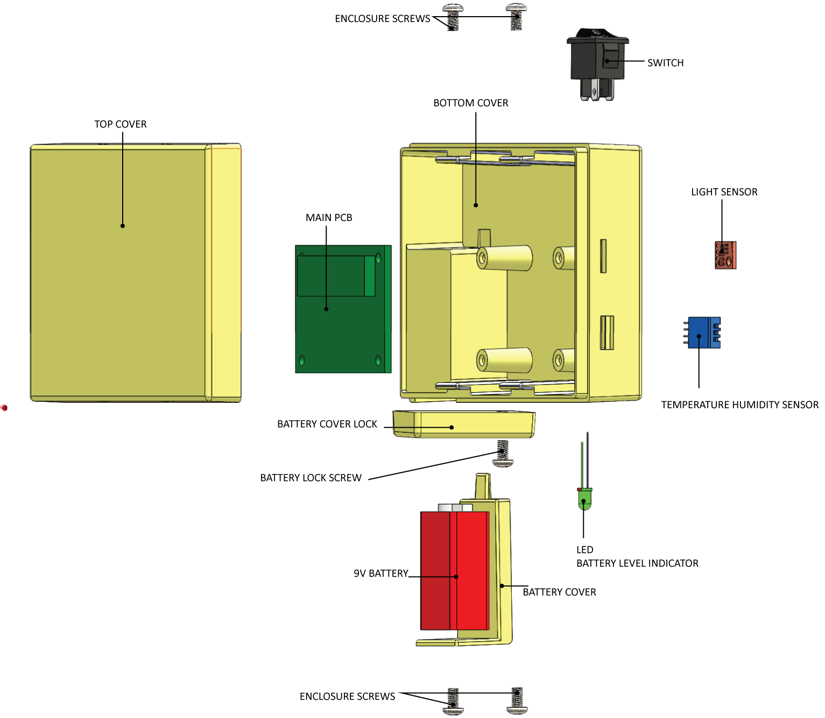

## Assembly Steps

1. Connect the LCD’s to the corresponding headers on the PCB (Refer Circuit Diagram).
2. Insert and secure the LCD’s into corresponding sockets
3. Mount the Fully soldered and tested PCB on the corresponding mounting holes
4. Insert screws and secure the PCB
5. Insert the Temperature, RH, Light and Soil Moisture Sensors into their corresponding sockets and secure.
6. Connect the above sensors using their corresponding polarized headers (See Circuit Diagrams for more information)
7. Insert the rocker switch and secure the battery connector in their corresponding positions.
8. Connect the rocker switch and battery connector to the corresponding places on the PCB
9. Insert the Battery Cover into the Battery Cover slot
10. Screw the Battery Lock into position, and rotate clockwise to secure the battery cover
11. Fit the top cover into position and secure the sides with screws.

# A picture containing screenshot Description automatically generatedDisplay Unit Assembly

## Assembly Steps

1. Connect the LCD’s to the corresponding headers on the PCB (Refer Circuit Diagram).
2. Insert and secure the LCD’s into corresponding sockets
3. Mount the Fully soldered and tested PCB on the corresponding mounting holes
4. Insert screws and secure the PCB
5. Connect the SD card Reader to the corresponding connector on the PCB and insert the SD card reader into its corresponding position and secure.
6. Insert the rocker switch and secure the battery connector in their corresponding positions.
7. Connect the rocker switch and battery connector to the corresponding places on the PCB.
8. Insert the Battery Cover into the Battery Cover slot, and screw into position.
9. Secure the LCD Screen to the inside of the Top Cover.
10. Secure the Keypad to its slot on the top cover, while taking its connector in through the front slot.
11. Connect both LCD and Keypad to the PCB in their correct positions.
12. Fit the top cover into position and secure the sides with locking screws.

# Processor Code

/* ---------------------------------------------------------------------------------------------------

[FILE NAME]: <Configuration Files.c>

[AUTHOR(S)]: <T.T.N Bahavan>

[DATE CREATED]: <6/19/2019>

[DESCRIPTION]: <Contains configuration files for LCD Unit>

---------------------------------------------------------------------------------------------------*/

#ifndef MICRO_CONFIG_H_

#define MICRO_CONFIG_H_

#ifndef F_CPU

#define F_CPU 10000000UL //8MHz Clock frequency

#endif

#include <avr/io.h>

#include <avr/interrupt.h>

#include <util/delay.h>

#include <string.h>

#include "std_types.h"

#include "common_macros.h"

#include "lcd.h"

#include "keypad.h"

#include "IntEEPROM.h"

#include "password.h"

#endif

/* MICRO_CONFIG_H_ */

/* ---------------------------------------------------------------------------------------------------

[FILE NAME]: <EEPROMCODE.c>

[AUTHOR(S)]: <T.T.N Bahavan>

[DATE CREATED]: <6/19/2019>

[DESCRIPTION]: <EEPROM>

---------------------------------------------------------------------------------------------------*/

#include "IntEEPROM.h"

void eepromWriteByte(unsigned short a_addr, unsigned char a_data)

{

/* Wait for completion of previous write */

while (EECR & (1 << EEWE))

;

/* Set up address and data registers */

EEAR = a_addr;

EEDR = a_data;

/* Write logical one to EEMWE */

EECR |= (1 << EEMWE);

/* Start EEPROM write by setting EEWE */

EECR |= (1 << EEWE);

}

unsigned char eepromReadByte(unsigned short a_addr)

{

/* Wait for completion of previous write */

while (EECR & (1 << EEWE))

;

/* Set up address register */

EEAR = a_addr;

/* Start EEPROM read by writing EERE */

EECR |= (1 << EERE);

/* Return data from data register */

return EEDR;

}

/* ---------------------------------------------------------------------------------------------------

[FILE NAME]: <KEYPAD CODE.c>

[AUTHOR(S)]: <T.T.N Bahavan>

[DATE CREATED]: <6/19/2019>

[DESCRIPTION]: <Contains the main function of the program>

---------------------------------------------------------------------------------------------------*/

#include "keypad.h"

uint8 KeyPad_getPressedKey(void){

uint8 col,row;

while(1)

{

for(col=0;col<N_col;col++) /* loop for columns */

{

/*

* each time only one of the column pins will be output and

* the rest will be input pins include the row pins

*/

KEYPAD_PORT_DIR = (0b00010000<<col);

/*

* clear the output pin column in this trace and enable the internal

* pull up resistors for the rows pins

*/

KEYPAD_PORT_OUT = (~(0b00010000<<col));

for(row=0;row<N_row;row++) /* loop for rows */

{

if(BIT_IS_CLEAR(KEYPAD_PORT_IN,row)) /* if the switch is press in this row */

{

#if (N_col == 3)

return KeyPad_4x3_adjustKeyNumber((row*N_col)+col+1);

#elif (N_col == 4)

return KeyPad_4x4_adjustKeyNumber((row*N_col)+col+1);

#endif

}

}

}

}

}

#if (N_col == 3)

uint8 KeyPad_4x3_adjustKeyNumber(uint8 button_number)

{

switch(button_number)

{

case 10: return '*'; // ASCII Code of =

break;

case 11: return 0;

break;

case 12: return '#'; // ASCII Code of +

break;

default: return button_number;

}

}

#elif (N_col == 4)

uint8 KeyPad_4x4_adjustKeyNumber(uint8 button_number)

{

switch(button_number)

{

case 1: return 7;

break;

case 2: return 8;

break;

case 3: return 9;

break;

case 4: return '%'; // ASCII Code of %

break;

case 5: return 4;

break;

case 6: return 5;

break;

case 7: return 6;

break;

case 8: return '*'; /* ASCII Code of '*' */

break;

case 9: return 1;

break;

case 10: return 2;

break;

case 11: return 3;

break;

case 12: return '-'; /* ASCII Code of '-' */

break;

case 13: return 13; /* ASCII of Enter */

break;

case 14: return 0;

break;

case 15: return '='; /* ASCII Code of '=' */

break;

case 16: return '+'; /* ASCII Code of '+' */

break;

default: return button_number;

}

}

#endif

/* ---------------------------------------------------------------------------------------------------

[FILE NAME]: <UART.c>

[AUTHOR(S)]: <T.T.N Bahavan>

[DATE CREATED]: <6/19/2019>

[DESCRIPTION]: <UART CODE>

---------------------------------------------------------------------------------------------------*/

#include "uart.h"

extern volatile uint8 g_choice;

void UART_init(void) {

UCSRA = (1 << U2X); /* U2X = 1 for double transmission speed */

/************************** UCSRB Description **************************

* RXCIE = 1 Enable USART RX Complete Interrupt Enable

* TXCIE = 0 Disable USART Tx Complete Interrupt Enable

* UDRIE = 0 Disable USART Data Register Empty Interrupt Enable

* RXEN = 1 Receiver Enable

* RXEN = 1 Transmitter Enable

* UCSZ2 = 0 For 8-bit data mode

* RXB8 & TXB8 not used for 8-bit data mode

***********************************************************************/

UCSRB = (1 << RXEN) | (1 << TXEN) | (1 << RXCIE);

/************************** UCSRC Description **************************

* URSEL = 1 The URSEL must be one when writing the UCSRC

* UMSEL = 0 Asynchronous Operation

* UPM1:0 = 00 Disable parity bit

* USBS = 0 One stop bit

* UCSZ1:0 = 11 For 8-bit data mode

* UCPOL = 0 Used with the Synchronous operation only

***********************************************************************/

UCSRC = (1 << URSEL) | (1 << UCSZ0) | (1 << UCSZ1);

/* baud rate=9600 & Fosc=8MHz --> UBBR=( Fosc / (8 * baud rate) ) - 1 = 103 */

UBRRH = 0;

UBRRL = 103;

}

void UART_sendByte(const uint8 data) {

/* UDRE flag is set when the Tx buffer (UDR) is empty and ready for

* transmitting a new byte so wait until this flag is set to one */

while (BIT_IS_CLEAR(UCSRA, UDRE)) {

}

/* Put the required data in the UDR register and it also clear the UDRE flag as

* the UDR register is not empty now */

UDR = data;

/************************* Another Method *************************

UDR = data;

while(BIT_IS_CLEAR(UCSRA,TXC)){} // Wait until the transimission is complete TXC = 1

SET_BIT(UCSRA,TXC); // Clear the TXC flag

*******************************************************************/

}

uint8 UART_recieveByte(void) {

/* RXC flag is set when the UART receive data so wait until this

* flag is set to one */

while (BIT_IS_CLEAR(UCSRA, RXC)) {

}

/* Read the received data from the Rx buffer (UDR) and the RXC flag

will be cleared after read this data */

return UDR;

}

void UART_sendString(const uint8 *Str) {

uint8 i = 0;

while (Str[i] != '\0') {

UART_sendByte(Str[i]);

i++;

}

/************************* Another Method *************************

while(*Str != '\0')

{

UART_sendByte(*Str);

Str++;

}

*******************************************************************/

}

void UART_receiveString(uint8 *Str) {

uint8 i = 0;

Str[i] = UART_recieveByte();

while (Str[i] != '#') {

i++;

Str[i] = UART_recieveByte();

}

Str[i] = '\0';

}

/* ---------------------------------------------------------------------------------------------------

[FILE NAME]: <Main Control Unit.c>

[AUTHOR(S)]: <T.T.N Bahavan>

[DATE CREATED]: <6/19/2019>

[DESCRIPTION]: <Contains the main function of the program>

---------------------------------------------------------------------------------------------------*/

#ifndef STD_TYPES_H_

#define STD_TYPES_H_

typedef unsigned char uint8;

typedef signed char sint8;

typedef unsigned short uint16;

typedef signed short sint16;

typedef unsigned long uint32;

typedef signed long sint32;

#endif /* STD_TYPE_H_ */

/* ---------------------------------------------------------------------------------------------------

[FILE NAME]: <ADC Unit for sensors.c>

[AUTHOR(S)]: <T.T.N Bahavan>

[DATE CREATED]: <6/19/2019>

[DESCRIPTION]: <ADC Conversion>

---------------------------------------------------------------------------------------------------*/

#include "atmega-adc.h"

void (*_adc_handler)(*uint8_t* pin, *uint16_t*);

volatile *uint8_t* _adc_pin_qty;

*uint16_t* adc_read(*uint8_t* prescaler, *uint8_t* vref, *uint8_t* pin) {

#ifdef MUX5

if (pin > 7) {

ADCSRB |= _BV(MUX5);

ADMUX = vref | (pin - 8);

} else {

ADCSRB &= ~(_BV(MUX5));

ADMUX = vref | pin;

}

#else

ADMUX = vref | pin;

#endif

ADCSRA = _BV(ADEN) | _BV(ADSC) | prescaler;

while(!(ADCSRA & _BV(ADIF)));

return (ADCL | (ADCH<<8));

}

void adc_start(*uint8_t* prescaler, *uint8_t* vref, *uint8_t* pin_qty, void (*handler)(*uint8_t*, *uint16_t*)) {

_adc_handler = handler;

_adc_pin_qty = pin_qty;

ADMUX = vref;

#ifdef MUX5

ADCSRB &= ~(_BV(MUX5));

#endif

ADCSRA = _BV(ADEN) | _BV(ADSC) | _BV(ADIE) | prescaler;

}

void adc_stop() {

ADCSRA = 0;

}

#ifdef ENABLE_ADC_INT

ISR(ADC_vect) {

static *uint8_t* cur_pin = 0;

_adc_handler(cur_pin, ADCL | (ADCH<<8));

cur_pin++;

if (cur_pin >= _adc_pin_qty)

cur_pin = 0;

#ifdef MUX5

if (cur_pin > 7) {

ADCSRB |= _BV(MUX5);

ADMUX = (ADMUX & 0xe0) | (cur_pin - 8);

} else {

ADCSRB &= ~(_BV(MUX5));

ADMUX = (ADMUX & 0xe0) | cur_pin;

}

#else

ADMUX = (ADMUX & 0xe0) | cur_pin;

#endif

ADCSRA |= _BV(ADSC);

}

#endif

## Sensor Unit Code

/* ---------------------------------------------------------------------------------------------------

[FILE NAME]: <Sensor UNIT.c>

[AUTHOR(S)]: <T.T.N Bahavan>

[DATE CREATED]: <6/19/2019>

[DESCRIPTION]: <Contains the code in the sensor unit>

---------------------------------------------------------------------------------------------------*/

#include "micro_config.h"

#include <avr/io.h>

#include <util/delay.h>

#include <stdio.h>

#include "atmega-adc.h"

#include <stdint.h>

/*------------------------------------------------All Variables---------------------------------------------------*/

uint8 flag = 0;

uint8 val; /*to read the value from EEPROM in it*/

uint8 TEMP[6];

uint8 HUMID[6];

uint8 SOILMOISTURE[6];

uint8 LIGHTLEVEL[6];

uint8 COMPOSITEDATA[24];

int main(void)

{

UART_init(); /* initialize UART */

sei();

while (1)

{

TEMP[6]=adc_read(128, aref, 0) ;

HUMID[6]=adc_read(128, aref, 1) ;

SOILMOISTURE[6]=adc_read(128, aref, 2) ;

LIGHTLEVEL[6]=adc_read(128, aref, 3) ;

COMPOSITEDATA = MakeComposite(TEMP[6],HUMID[6],SOILMOISTURE[6],LIGHTLEVEL[6],COMPOSITEDATA[24]);

UART_sendString(COMPOSITEDATA) {

}

}

## LCD CODE

/* ---------------------------------------------------------------------------------------------------

[FILE NAME]: <Sensor UNIT.c>

[AUTHOR(S)]: <T.T.N Bahavan>

[DATE CREATED]: <6/19/2019>

[DESCRIPTION]: <Contains the code in the sensor unit>

---------------------------------------------------------------------------------------------------*/

#include "micro_config.h"

#include <avr/io.h>

#include <util/delay.h>

#include <stdio.h>

#include "atmega-adc.h"

#include <stdint.h>

/*------------------------------------------------All Variables---------------------------------------------------*/

uint8 flag = 0;

uint8 val; /*to read the value from EEPROM in it*/

uint8 TEMP[6]; //DETERMINED BY UART DATA

uint8 HUMID[6];

uint8 SOILMOISTURE[6];

uint8 LIGHTLEVEL[6];

uint8 MAXTEMP[6]; //SET BY THE USER ACCORDING TO SPECIFICATIONS REQUIRED

uint8 MINHUMID[6];

uint8 MINSOILMOISTURE[6];

uint8 MAXLIGHTLEVEL[6];

int main(void)

{

UART_init(); /* initialize UART */

LCD_init();

sei();

if !(UART_RECEIVED){

LCD_DISPLAY(0,0,"Waiting");

}

else {

while (1)

{//Display the stuff

//If button press start the other program

LCD_clearScreen();

LCD_displayStringRowColumn(0, 0, "Temp : "+TEMP);

LCD_displayStringRowColumn(0, 0, "Temp : "+HUMID);

LCD_displayStringRowColumn(0, 0, "Temp : "+SOILMOISTURE);

LCD_displayStringRowColumn(0, 0, "Temp : "+LIGHTLEVEL);

inputChoise1 = KeyPad_getPressedKey();

//Start changing the data

if (inputChoise1 == '+')

{

//Display Choices

LCD_clearScreen();

LCD_displayStringRowColumn(0, 0, "- : Change Temp");

LCD_displayStringRowColumn(1, 0, "+ : Change RH");

LCD_displayStringRowColumn(0, 5, "- : Change Soil Moisture");

LCD_displayStringRowColumn(1, 5, "+ : Change Light Level");

inputChoise2 = KeyPad_getPressedKey();

if (inputChoise2 == '+')

{ LCD_clearScreen();

LCD_displayStringRowColumn(0, 0, "RH");

getValue(RH);

}else{

LCD_clearScreen();

LCD_displayStringRowColumn(0, 0, "Temp");

getValue(Temp);

LCD_displayStringRowColumn(0, 0, "Soil Moisture");

getValue(RH);

}else{

LCD_clearScreen();

LCD_displayStringRowColumn(0, 0, "Light Level");

getValue(Temp);

}

}}

}

}